THE OFFICIAL GAZETTE 6TH AUGUST, 2014
LEGAL SUPPLEMENT — A

GUYANA

ACT No. 13 of 2014

SUMMARY JURISDICTION (APPEALS) (AMENDMENT) ACT 2014

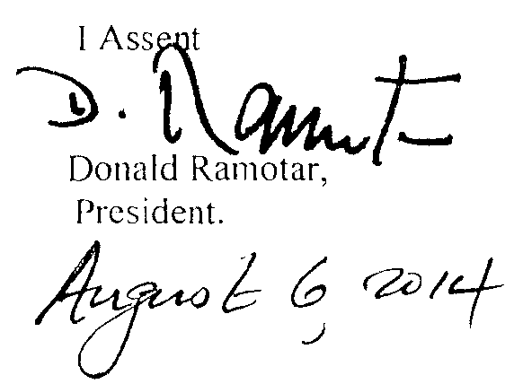

ARRANGEMENT OF SECTIONS

SECTION

1. Short title.
2. Amendment of section 12 of the Principal Act.

AN ACT to amend Summary Jurisdiction (Appeals) Act.

A.D. 2014  Short title.  Cap. 304  Amendment of section 12 of the Principal Act. |  | Enacted by the Parliament of Guyana:-  1. This Act, which amends the Summary Jurisdiction (Appeals) Act, may be cited  as the Summary Jurisdiction (Appeals) (Amendment) Act 2014.  2. Section 12 of the Principal Act is amended as follows-  (a) in the marginal note, by the substitution for the words “Suspension of execution” of the words “Decision under appeal”;  (b) by the substitution for subsection (1) of the following subsection as subsection (1) -  “(1) Subject to this section, on compliance by the appellant with the provisions of sections 4 and 5, an appeal shall not operate as stay of the execution of the decision under appeal:  Provided that a magistrate whose decision is likely to be appealed, may grant a stay of execution of that decision for a period not exceeding four weeks from the date of the decision upon an application made at the time of the delivery of the said decision.”;  (c) by the deletion of subsection (2).

Passed by the National Assembly on 10th July, 2014.

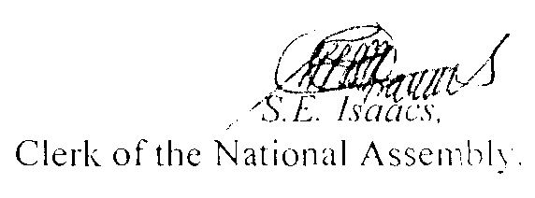

(BILL No. 9/2014)

2

