THE OFFICIAL GAZETTE 17TH JUNE, 2014
LEGAL SUPPLEMENT — A

GUYANA

ACT NO. 11 OF 2014

MARRIED PERSONS (PROPERTY) (AMENDMENT) ACT 2014

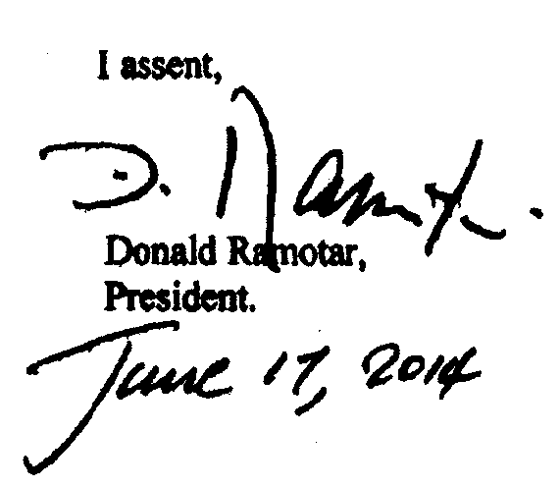

ARRANGEMENT OF SECTIONS

SECTION

1. Short title.
2. Insertion of new section 15A in the Principal Act.

AN ACT to amend the Married Persons (Property) Act.

A.D. 2014  Short title.  Cap. 45:04  Insertion of new section 15A in the Principal Act. |  | Enacted by the Parliament of Guyana:-  1. This Act, which amends the Married Persons (Property) Act, may be cited as the Married Persons (Property) (Amendment) Act 2014.  2. The Principal Act is hereby amended by the insertion after section 15 of the following section as section 15A -
 |  | “Dissolution or annulment of the marriage or union. |  | 15A. An application may be made to a Judge under section 6A and section 15 by either of the parties to the marriage or the union notwithstanding that their marriage has been dissolved or annulled, or their union ended, if the application is made within three years after the dissolution or annulment of the marriage or the end of the union.”.

Passed by the National Assembly on 15th May, 2014.

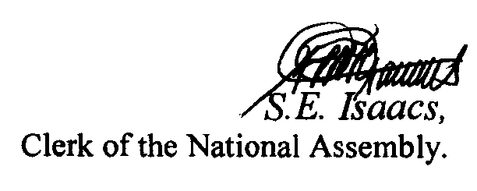

(Bill No. 9/2013)

2

