THE OFFICIAL GAZETTE 16TH APRIL, 2014
LEGAL SUPPLEMENT — A

GUYANA

ACT NO. 9 OF 2014

CARIBBEAN COMMUNITY (FREE ENTRY OF SKILLED NATIONALS)
(AMENDMENT) ACT 2014

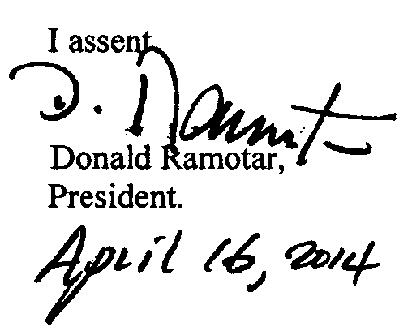

ARRANGEMENT OF SECTIONS

SECTION

1. Short title.
2. Amendment of section 2 of the Principal Act.
3. Insertion of new section 4A in the Principal Act.
4. Amendment of section 10 of the Principal Act.

AN ACT to amend the Caribbean Community (Free Entry of Skilled Nationals) Act.

A.D. 2014  Short title.  Cap. 93:02  Amendment of section 2 of the Principal Act.  Insertion of section 4A in the Principal Act.  Amendment of section 10 of the Principal Act. | “Verification of a certificate issued by a qualifying State. | Enacted by the Parliament of Guyana:-  1. This Act, which amends the Caribbean Community (Free Entry of Skilled Nationals) Act, may be cited as the Caribbean Community (Free Entry of Skilled Nationals) (Amendment) Act 2014.  2. Section 2 of the Principal Act is amended as follows –  (a) by inserting, immediately before the definition of “immigration officer”, the following definition –  ‘ “dependent” in relation to a person means –  (a) any unmarried child of that person -  (i) under the age of eighteen years;  (ii) under the age of twenty-five years attending school or university full time;  (iii) over the age of eighteen years who, due to disability, is wholly dependent on that person,  whether born in or out of wedlock and includes a step child, a child adopted by law or a child of the family;  - a parent who is wholly dependent on that person for his subsistence;  - any other natural person certified as such by order of court;’;  (b) by inserting, immediately after the definition of “immigration officer”, the following definition -  ‘ “Minister” means the Minister assigned with responsibility for foreign affairs;’.  3. The Principal Act is amended by inserting, immediately after section 4, the following section as section 4A -  4A. (1) A person who –  (a) is granted permission under section 4 to enter and remain in Guyana for six months; and  (b) wishes to remain in Guyana for a period of indefinite duration.  2  shall apply to the Minister to have the certificate issued to him by a qualifying State verified.  (2) The Minister may, notwithstanding the verification of a certificate issued by a qualifying State, disregard that certificate where it is afterwards found that the applicant has been convicted -  (a) of an offence under section 14;  (b) in a qualifying State of a similar offence to that stated under section 14; or  (c) of any serious offence, whether in Guyana or elsewhere.  (3) Where the Minister, after verification of a certificate issued by a qualifying State, finds that the certificate complies with the requirements of a Schedule II Certificate and the person has not breached any other law, the Minister shall inform the Chief Immigration Officer of the verification and the person to whom this section relates may apply to the Chief Immigration Officer for permission to remain in Guyana for a period of indefinite duration.”.  4. Section 10 of the Principal Act is amended as follows -  (a) in subsection 1 (c), by inserting immediately after the word “his”, the words “or his spouse’s”;  (b) in subsection (2), by substituting the following subsection as subsection (2) –  “ (2) Subject to sections 11, 13 and 14 and notwithstanding any other law a person, who is granted a permission under section 4, shall for the duration of the permission, as in the case of a citizen of Guyana, not be subject to –  (a) any restriction on his or his spouse and dependent members of his family’s freedom of movement, including the freedom to leave and re-enter Guyana without further permission; or  (b) any restriction on his right to engage in gainful employment or other occupation.”.

Passed by the National Assembly on 27th February, 2014.

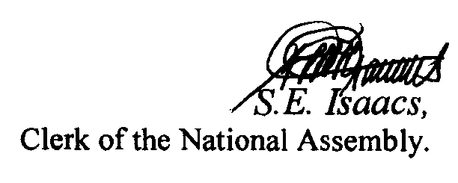

(BILL No. 5/2014)

3

