THE OFFICIAL GAZETTE 8TH MAY, 2014
LEGAL SUPPLEMENT — A

GUYANA

ACT NO. 5 OF 2014

DEEDS REGISTRY (AMENDMENT) ACT 2014

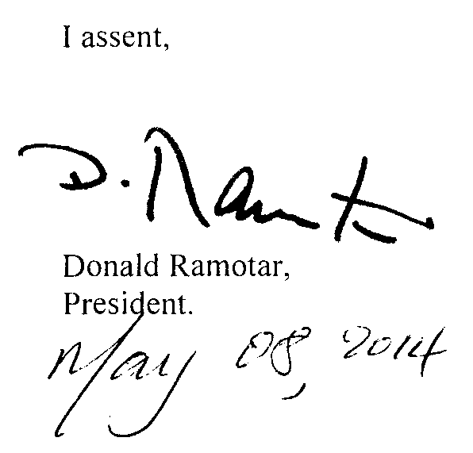

ARRANGEMENT OF SECTIONS

SECTION

1. Short title.
2. Amendment of section 7 of the Principal Act.
3. Insertion of new section 22A in the Principal Act.
4. Insertion of Form 3 in the Third Schedule.

AN ACT to amend the Deeds Registry Act..

A.D. 2014  Short title.  Cap. 5:01  Amendment of section 7 of the Principal Act.  Insertion of new section 22A in the Principal Act.  Insertion of Form 3 in the Third Schedule. | “Prohibitions.  Third Schedule. | Enacted by the Parliament of Guyana:-  1. This Act, which amends the Deeds Registry Act, may be cited as the Deeds Registry (Amendment) Act 2014..  - Section 7 of the Principal Act is amended as follows –  (a) in paragraph (f) by the insertion immediately after the word “diagrams,” of the words “prohibitions in respect of written agreements of sale of immovable property,”;  (b) in paragraph (i) by the insertion immediately after the word “servitude,” of the words “prohibition in respect of a written agreement of sale of immovable property,”;  (c) in paragraph (k) by the substitution for the word “and” where it occurs for the first time of a comma and by the insertion immediately after the word “mortgage” of the words “and prohibitions in respect of written agreements of sale of immovable property”.  3. The Principal Act is amended by the insertion immediately after section 22 of the following section as section 22A –  22A. (1) For the prevention of any dealing with any immovable property, that is the subject of a written agreement of sale without prior notice to the purchaser, any purchaser, his assignee or successor claiming to be entitled to the conveyance of the immovable property under the said written agreement of sale, may lodge the following with the Registrar –  (a) a prohibition in Form 3 in the Third Schedule verified by a statutory declaration; and  (b) a copy of the written agreement of sale.  (2) For the purposes of lodging a prohibition, a written agreement of sale shall -  (a) be valid and subsisting;  (b) specify that the purchaser has paid a deposit of at least ten percent of the purchase price;  2  (c) specify a time for completion and passing of transport; and  (d) be lodged within the period specified in the agreement for the completion and passing of the transport.  (3) The Registrar shall not accept a prohibition unless it identifies an address for service in Guyana.  (4) Upon lodgement of any prohibition, the Registrar shall –  (a) enter a memorial in a register kept for that purpose;  (b) annotate same on the original grosse; and  (c) give notice within seven days of the lodgement of the prohibition to the vendor of the land affected.  (5) A prohibition may be removed from the registerwith the consent of the prohibitor in the form of an affidavit sworn to by the prohibitor or by order of the Court.  (6) Upon the application of the owner of any land affected by a prohibition, the Court may summon the prohibitor to attend before the Court to show cause why the prohibition should not be removed and the Court may thereupon make such order including an order removing the prohibition and as to cost as the Court thinks fit.  (7) If instruments or documents in the appropriate form intending to effect another conveyance, mortgage or charge on the land which is the subject of a prohibition are presented for filing in the Registry, the Registrar shall –  (a) give notice to the prohibitor; and  (b) suspend processing of the documents for eight weeks from the date of the notice.  (8) At the expiration of the period mentioned in subsection (7) (b), unless the prohibitor has commenced proceedings before the Court to restrain the conveyance, mortgage or charge to which the prohibition relates, the prohibition shall lapse and the instruments or documents presented under subsection (7)shall be deemed filed and processed as at the date of presentation.  (9) If no action is brought in the manner and within the time mentioned in the preceding subsections, the owner of the land may apply ex-parte to the Court for an order that the prohibition be declared abandoned, and upon production by the applicant of a certificate of the Registrar that no action has been so brought, the Court shall make the order and may therein deal with the costs of the proceedings in prohibition as the Court thinks fit.  3  (10) Nothing in this section shall operate to prevent a transaction if the memorial of the prohibition is removed from the register before the period of suspension has expired.  (11) No land or interest affected by a prohibition may be made the subject of any further prohibition so as to defeat the provisions of subsection (6).  (12) If a purchaser lodges a prohibition without reasonable cause, he shall be liable in damages to any person who may have suffered loss thereby.  (13) A prohibition shall operate to prevent any disposition of land affected thereby, subject to subsections (6), (7), (8), (9) and (10) and in any event, no longer than one year from the date of lodgement.  (14) A prohibition may be renewed at the end of one year subject to subsection (9).  4. The Third Schedule to the Principal Act is amended by inserting immediately after Form 2, the following Form as Form 3 -  “FORM 3  PROHIBITION  To the Registrar of Deeds  Take notice that I,…………………. of ……………………. claim to be entitled to a conveyance in and to the following property:  …………………………………………………………………………………………….  now standing in the name of ………………….. of………………………………………  pursuant to a written agreement of sale and purchase dated…………………….. attached hereto and I forbid the conveyance, mortgage or charge of this property to any third party until after notice of the intended conveyance or mortgage has been given to me.  Particulars upon which such claim is founded:  ………………………………………………………………………………………  My address for service is:………………………………………………………….  …………………………………………...  Signature of Prohibitor (Attorney-at-Law)  4  STATUTORY DECLARATION  I, the above-named……………… (or Attorney-at-Law) do solemnly and sincerely declare that the statements in the above prohibition are true in substance and in fact and the agreement dated……………….. in respect of the property the subject of this prohibition is valid and subsisting and meets the requirements as laid out in the Deeds Registry Act (as I have been informed by the above-named…………… and verily believe) I make this declaration.”.

Passed by the National Assembly on 16th January, 2014.

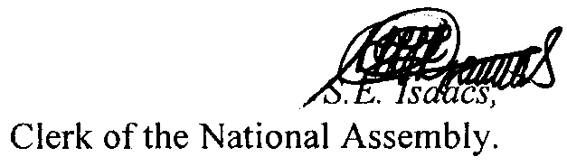

(BILL No. 11/2012)

5

