THE OFFICIAL GAZETTE 14TH MARCH, 2016
LEGAL SUPPLEMENT — A

GUYANA

ACT NO. 14 of 2016

TAX (AMENDMENT) ACT 2016

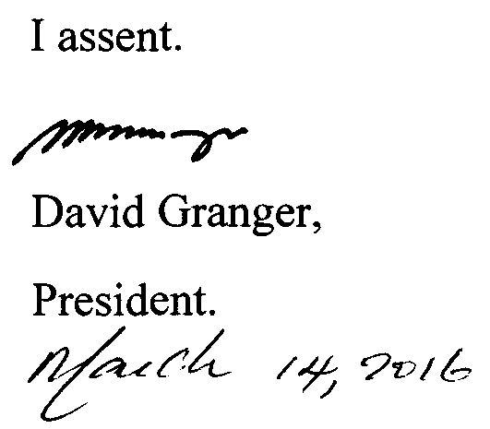

ARRANGEMENT OF SECTIONS

SECTION

1. Short title.
2. Amendment of the Principal Act.
3. Insertion of new section 73 in the Principal Act.

AN ACT to amend the Tax Act.

A.D. 2016  Short title.  Cap. 80:01  Amendment of the Principal Act. |  | Enacted by the Parliament of Guyana:-  1. This Act, which amends the Tax Act, may be cited as the Tax (Amendment) Act 2016.  2. The provisions of the Principal Act specified in column one of the TABLE are amended in the manner specified in the corresponding entries in colum two of the TABLE below-

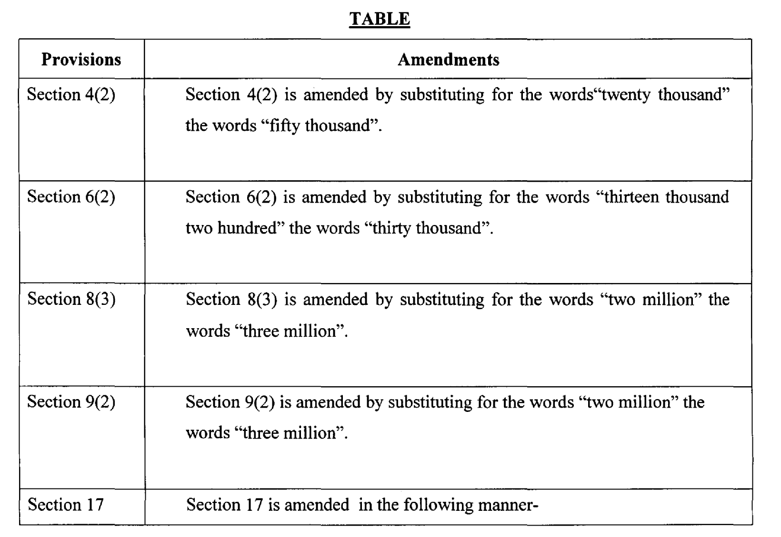

2

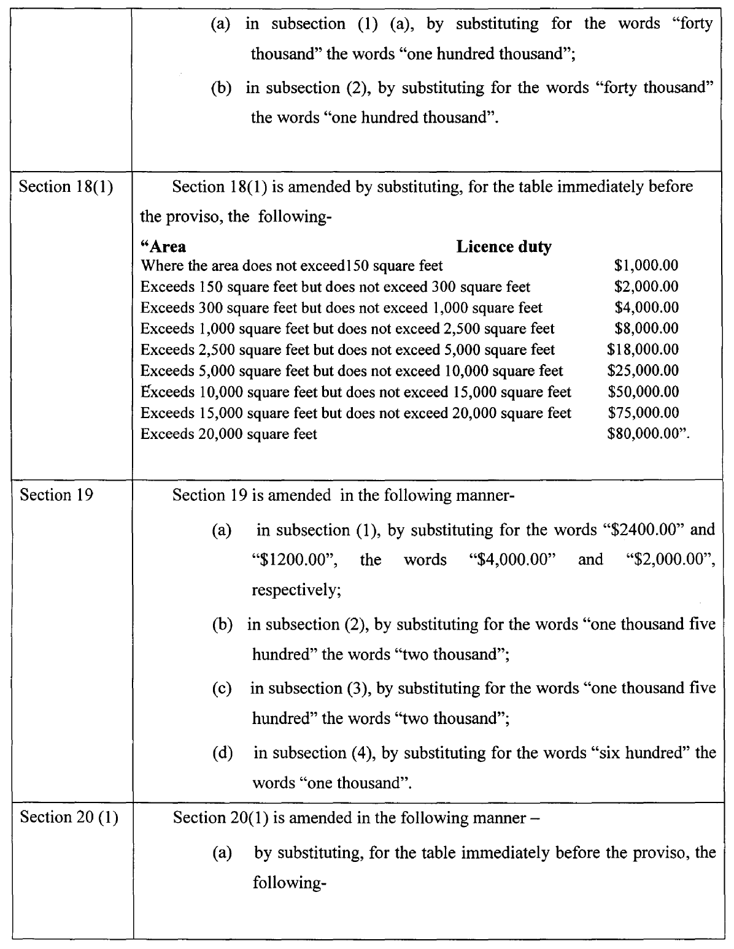

3

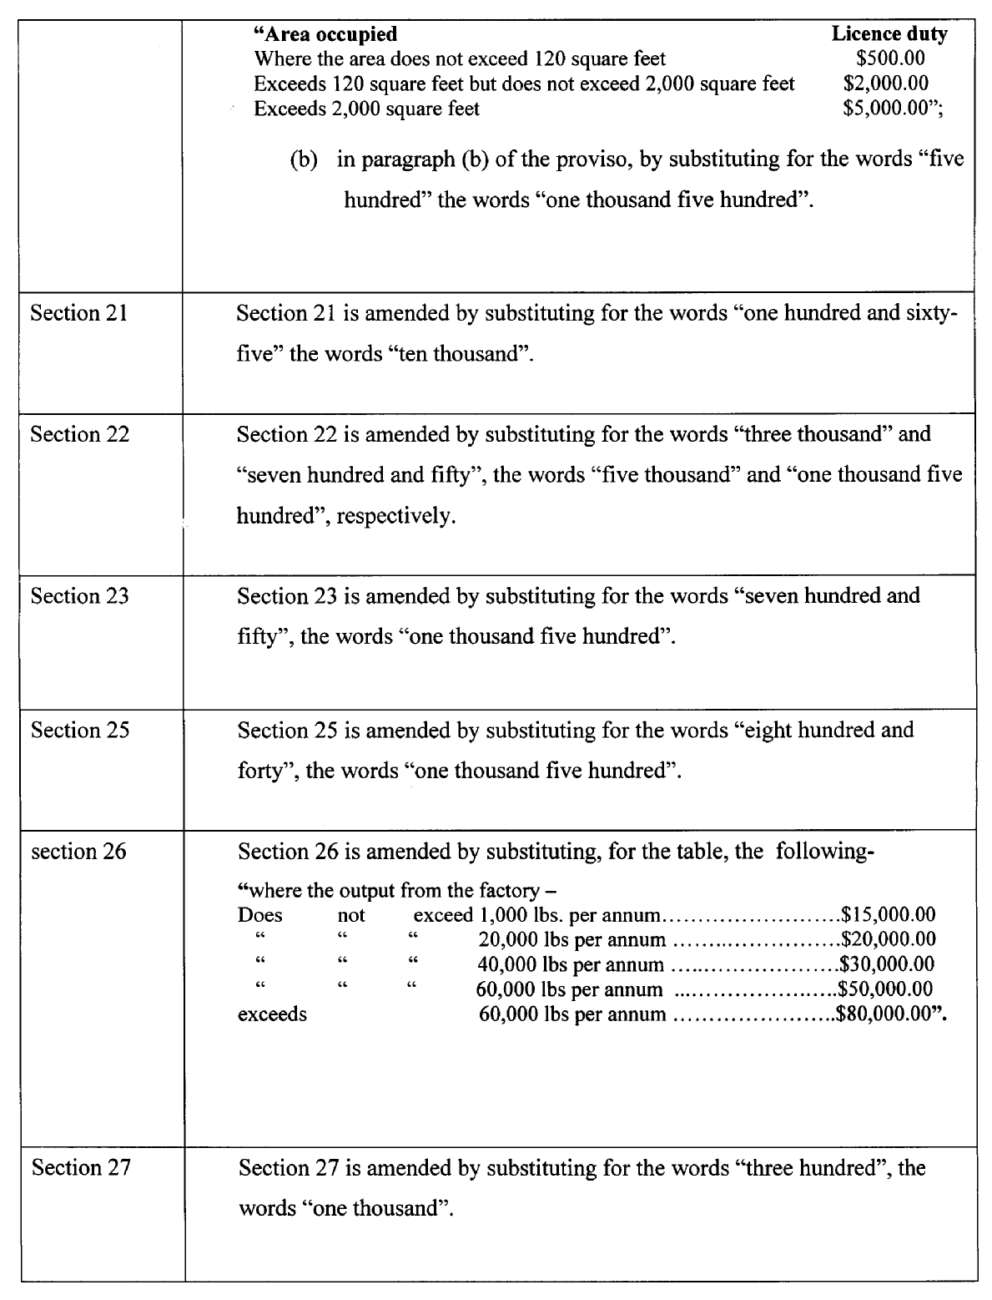

4

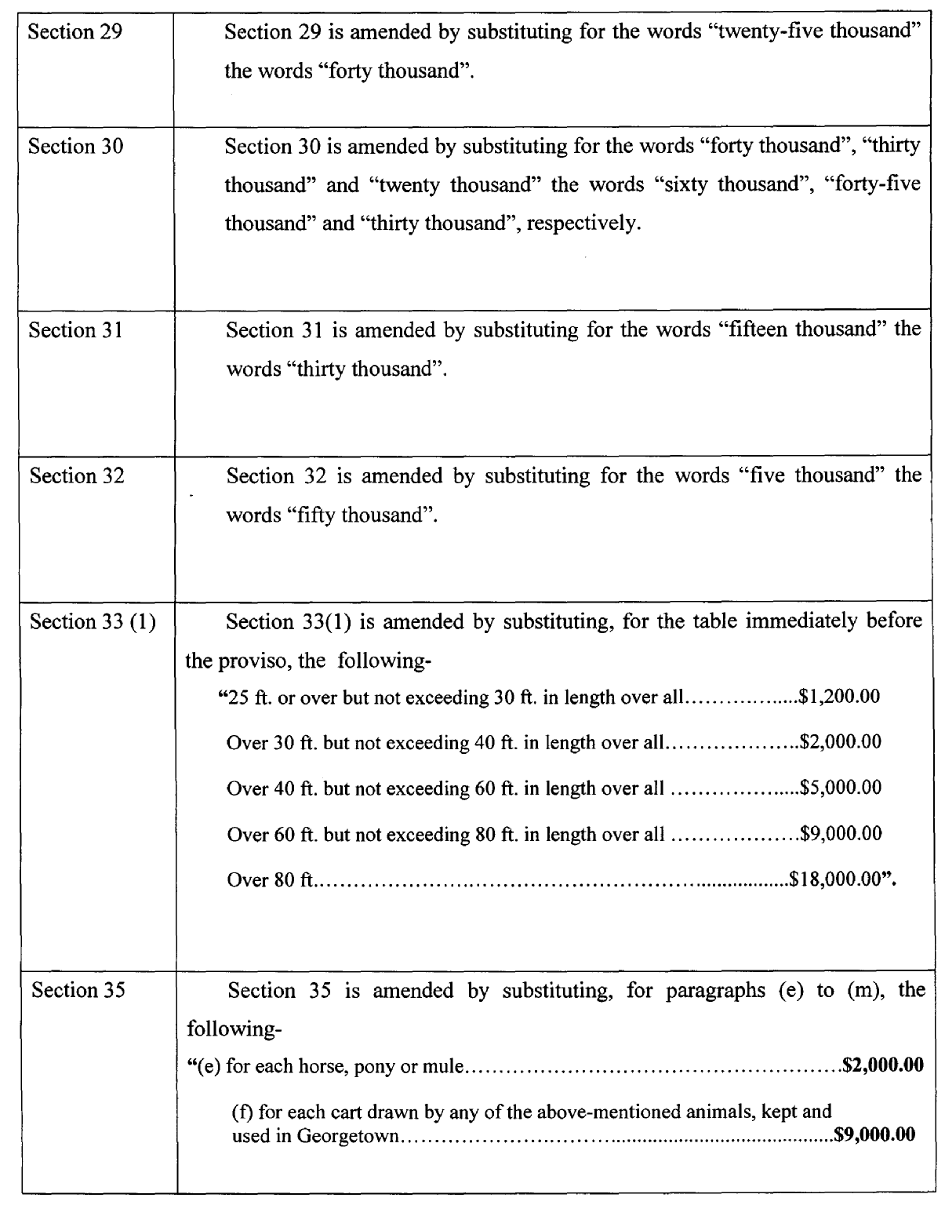

5

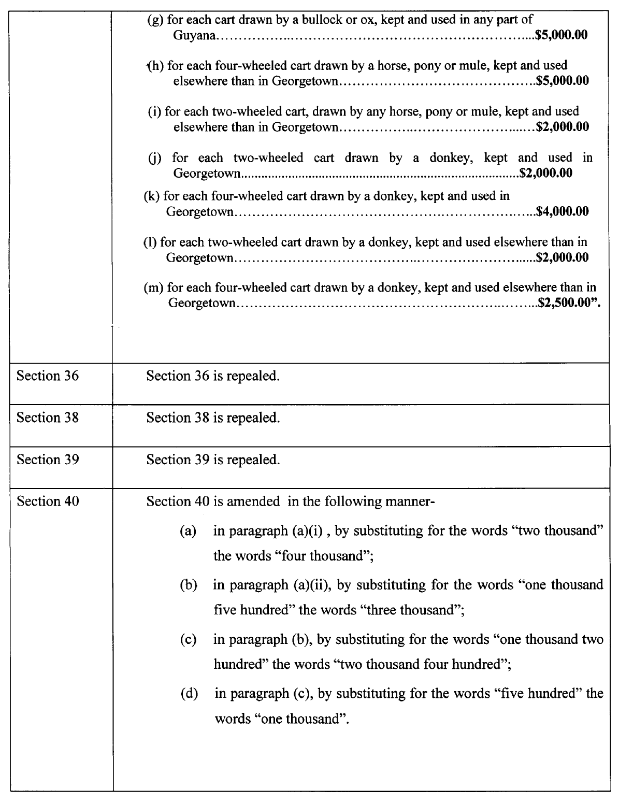

6

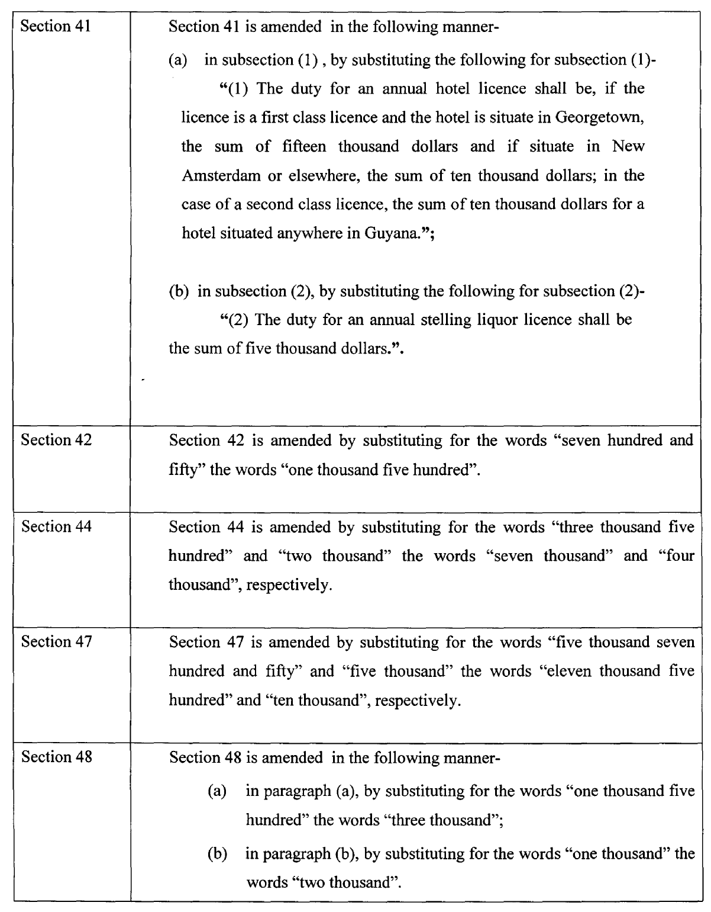

7

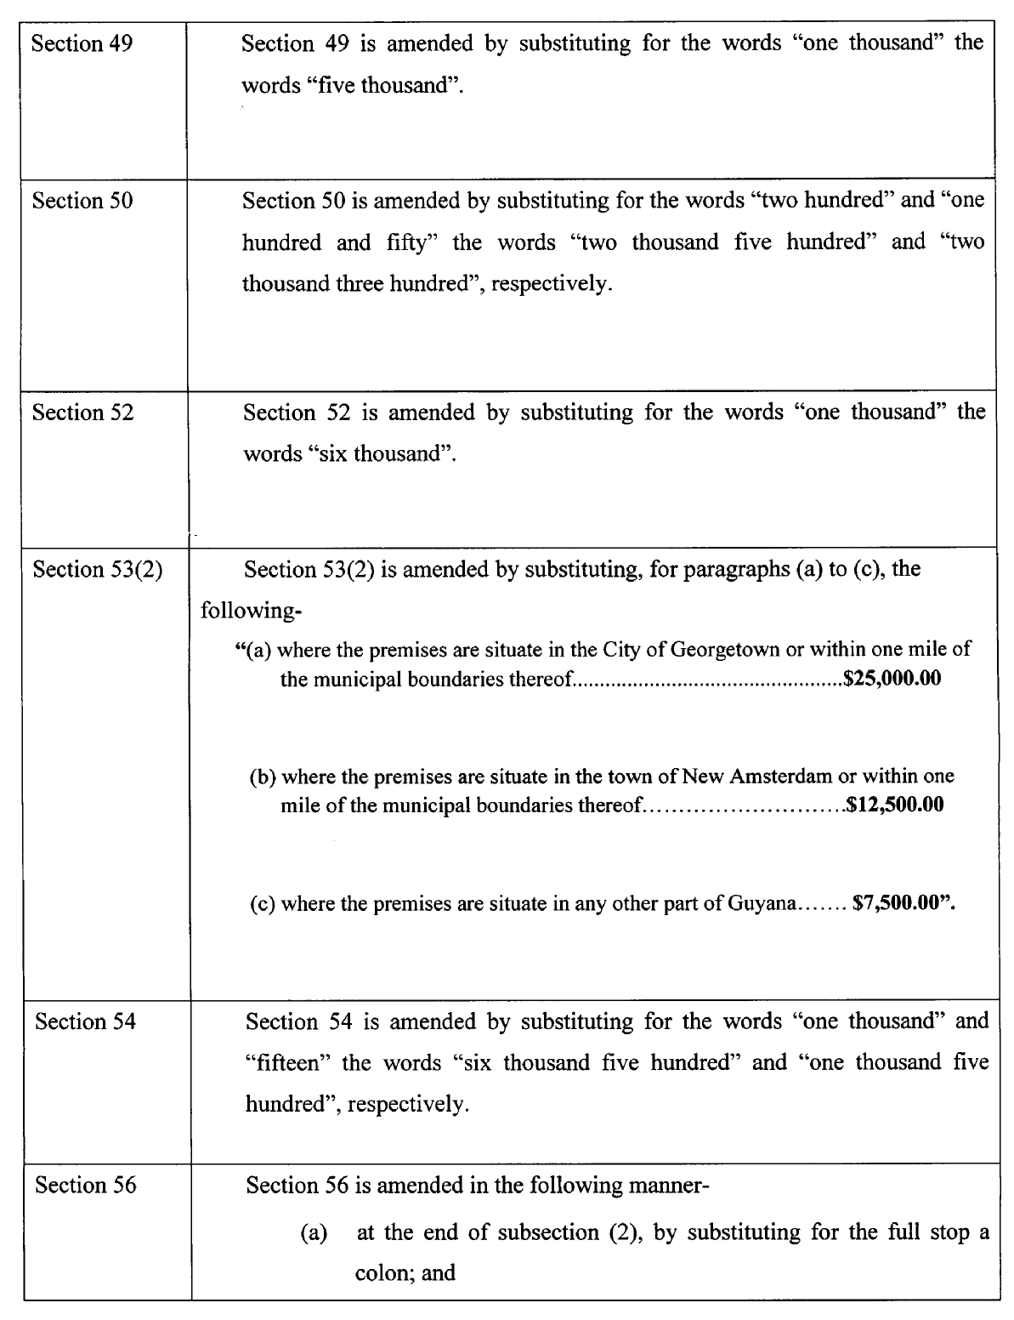

8

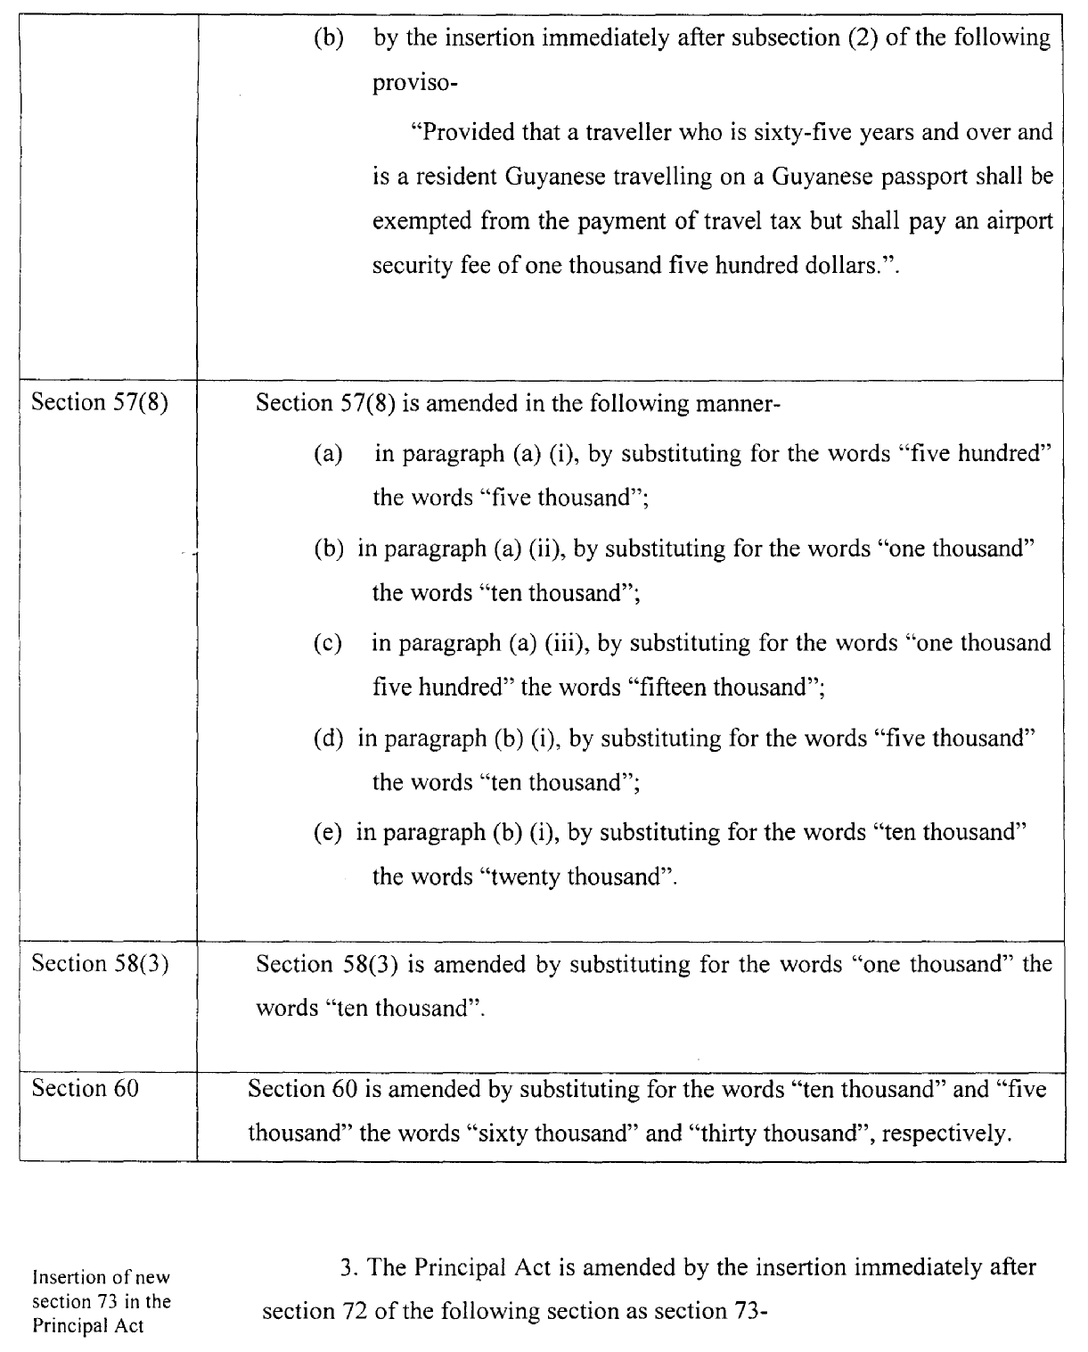

9

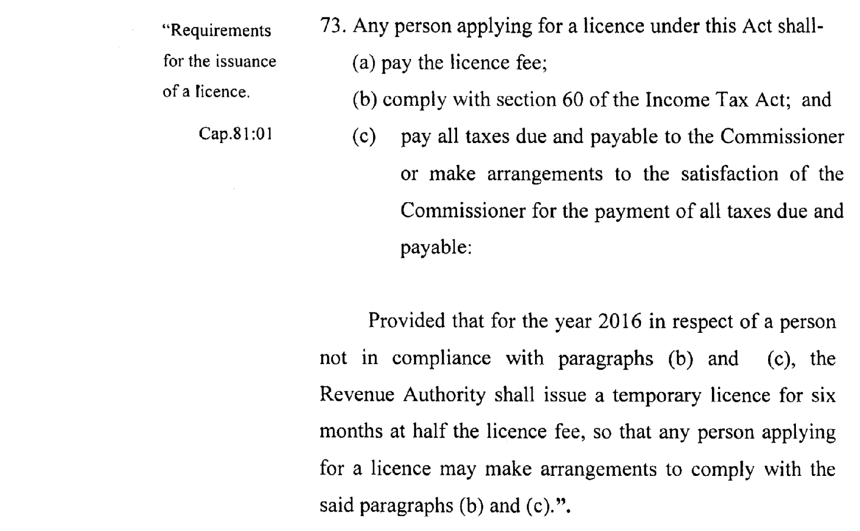

Passed by the National Assembly on the 26th February, 2016

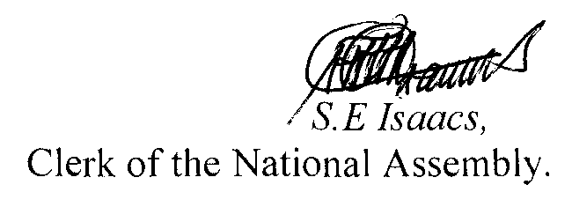

(BILL No. 10/2015)

10

