THE OFFICIAL GAZETTE 25TH JANUARY, 2016
LEGAL SUPPLEMENT — A

GUYANA

ACT NO. 3 OF 2016

CORONERS (AMENDMENT) ACT 2016

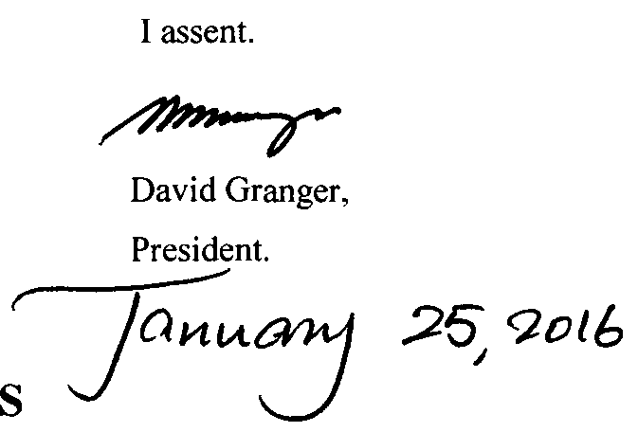

ARRANGEMENT OF SECTIONS

SECTION

1. Short title.
2. Amendment of the Principal Act.

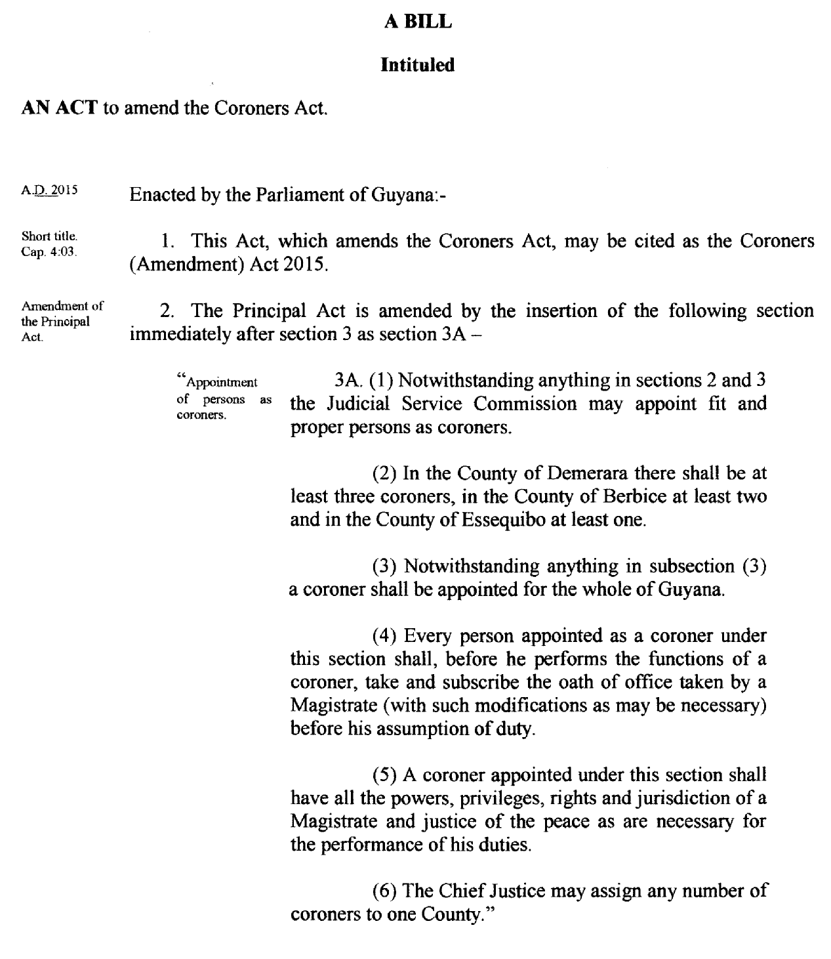

Passed by the National Assembly on the 14th January, 2016.

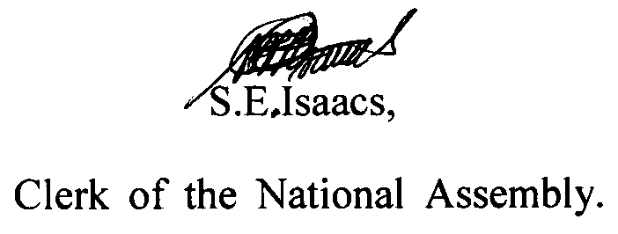

(Bill No. 11 of 2015)

