THE OFFICIAL GAZETTE 25TH JANUARY, 2016
LEGAL SUPPLEMENT — A

GUYANA

ACT NO. 2 OF 2016

CREDIT REPORTING (AMENDMENT) ACT 2016

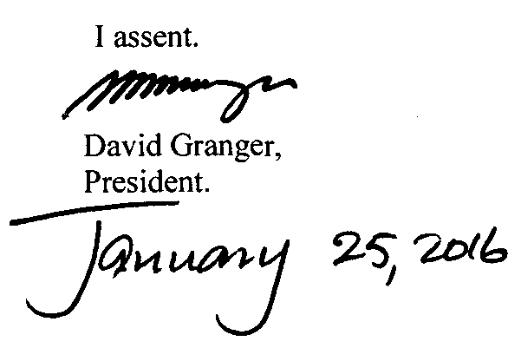

ARRANGEMENT OF SECTIONS

SECTION

1. Amendment of section 11 of the Principal Act.
2. Amendment of section 12 of the Principal Act.
3. Amendment of section 13 of the Principal Act.
4. Amendment of section 14 of the Principal Act.

AN ACT to amend the Credit Reporting Act.

A. D. 2016  Short title.  Cap. 84:01  Amendment of section 11 of the Principal Act.  Amendment of section 12 of the Principal Act. |  | Enacted by the Parliament of Guyana:-  1. This Act, which amends the Credit Reporting Act, may be cited as the Credit Reporting (Amendment) Act 2016.  2. Section 11 of the Principal Act is amended by the insertion immediately after subsection (2) of the following as subsection (3) –  “(3) Credit information providers referred to in section 12 (2) shall submit a request to a credit bureau for a credit report about a consumer before granting credit facilities or renewing credit facilities to a consumer in order to carry out an evaluation on credit risk.”.  3. Section 12 of the Principal Act is amended as follows –  (a) by the insertion immediately after subsection (2) of the following as subsection (2A) –  “(2A) The credit information providers referred to in subsection (2) shall share credit information on all persons to whom they extend credit facilities in their portfolio to a credit bureau.”;  (b) in subsection (7) –  (i) by the insertion in the opening lines immediately after word “sources” of the following words “and these public sources shall share the same to a credit bureau”;  (ii) in paragraph (d) by the substitution of a semicolon for the full stop at the end;  (iii) by the insertion immediately after paragraph (d) of the following as paragraph (e) –  “(e) utility companies.”.

Amendment of section 13 of the Principal Act.  Amendment of section 14 of the Principal Act. |  | 4. Section 13 of the Principal Act is amended as follows –  (a) in subsection (1) by the deletion of the word “not”;  (b) in subsection (2) by the substitution for the word “Consent” of the following words –  “A credit information provider shall not submit a request to the credit bureau to obtain credit information on a consumer without the consumer’s prior written consent which”.  (c) in subsection (4) in the penultimate line by the insertion of a full stop after the word “bureau” and by the deletion of all the remaining words in that subsection;  (d) in subsection (5) by the subsection for the word (1) of the words “(2)”.  5. Section 14 of the Principal Act is amended by the insertion of the following two subsections as subsections (4) and (5) –  “(4) Where a credit information provider is unable to satisfy itself of the reliability of the information it is required to supply to a credit bureau, it shall take immediate steps to verify the data and provide a report to the credit bureau within three months or provide a written report to the Bank stating the reasons why it is unable to verify the data.  (5) Where the report referred to in subsection (4) is made to the Bank a credit  information provider shall abide by any directions given to it by the Governor of the Bank in relation to that report.”

Passed by the National Assembly on 14th January, 2016.

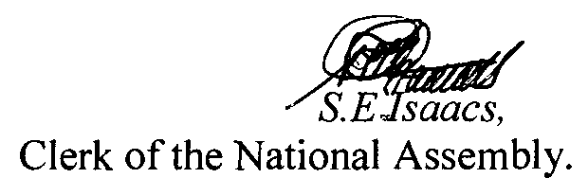

(BILL No. 13/2015)

