THE OFFICIAL GAZETTE 11TH JANUARY, 2016
LEGAL SUPPLEMENT — A

GUYANA

ACT No. 1 of 2016

CONSTITUTION (AMENDMENT) ACT 2016

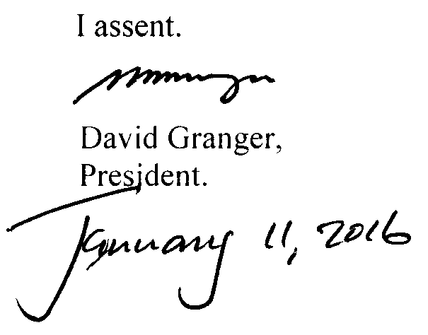

ARRANGEMENT OF SECTIONS

SECTION

1. Short title.
2. Amendment of the Third Schedule to the Constitution.

AN ACT to amend the Third Schedule relating to article 222A of the Constitution to insert The Parliament Office among the list of constitutional bodies.

A.D. 2016  Short title.  Amendment of the Third Schedule to the Constitution. |  | Enacted by the Parliament of Guyana:-  1. This Act, which amends the Constitution, may be cited as the Constitution (Amendment) Act 2016.  2. The Third Schedule to the Constitution is amended by the addition to the Schedule of The Parliament Office.

Passed by the National Assembly on the 7th January, 2016.

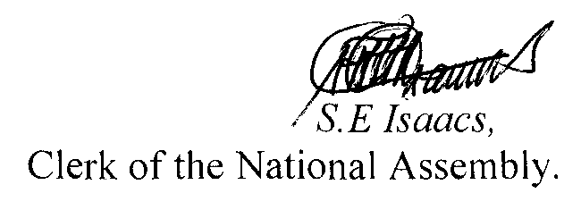

(BILL No. 20/2015)

