THE OFFICIAL GAZETTE 6TH JANUARY, 2016
LEGAL SUPPLEMENT — A

GUYANA

ACT NO. 13 of 2015

SUPPLEMENTARY APPROPRIATION (NO. 1 ACT 2015)

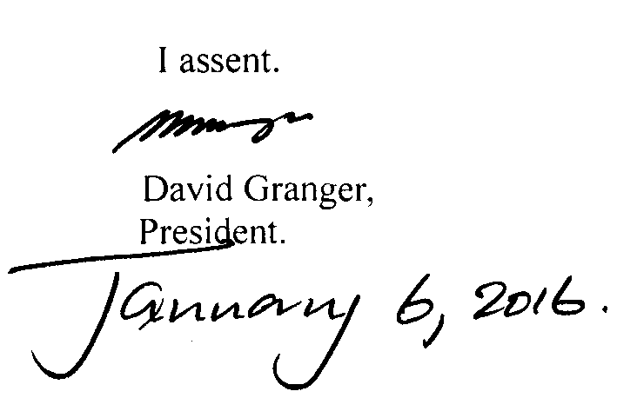

ARRANGEMENT OF SECTIONS

SECTION

1. Short title.
2. Issue from the Consolidated Fund authorised.
3. Appropriation.

Schedule.

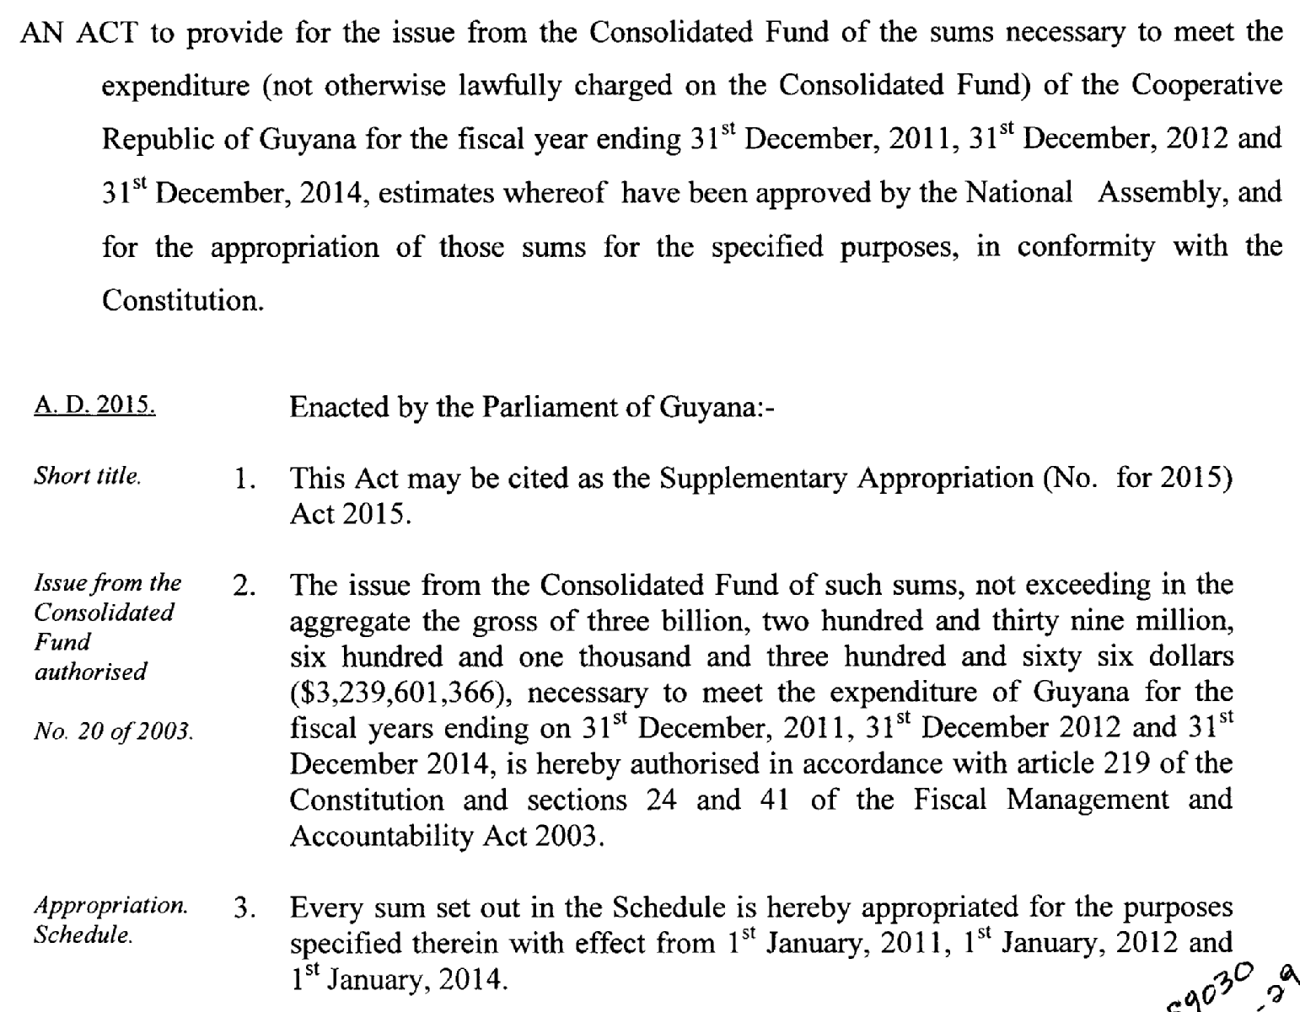

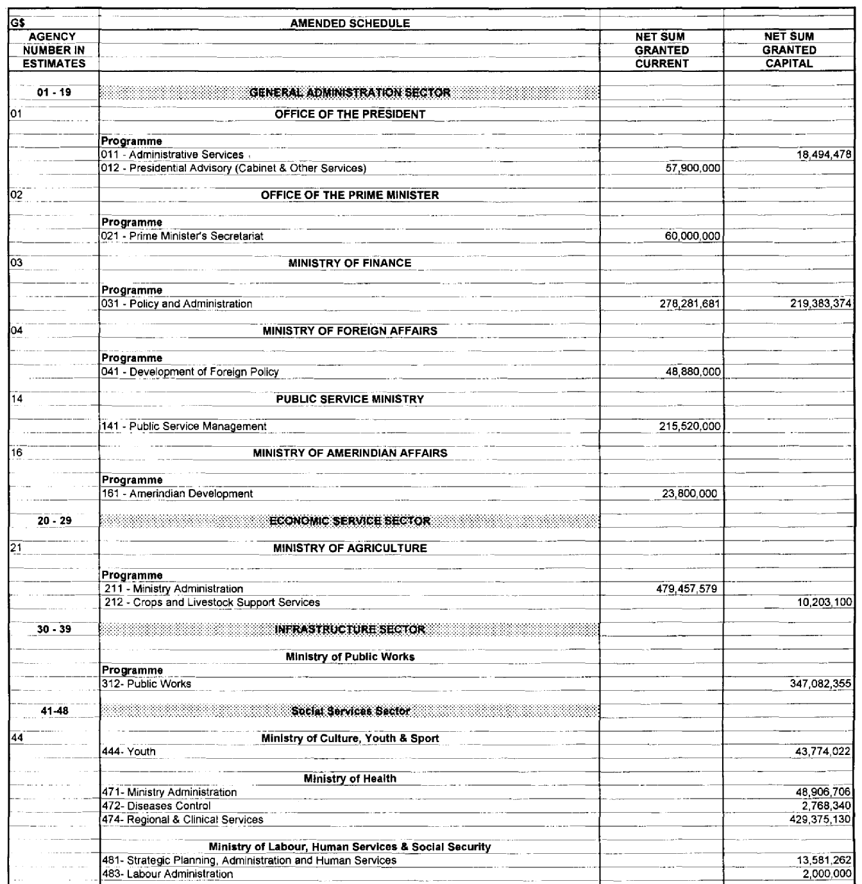

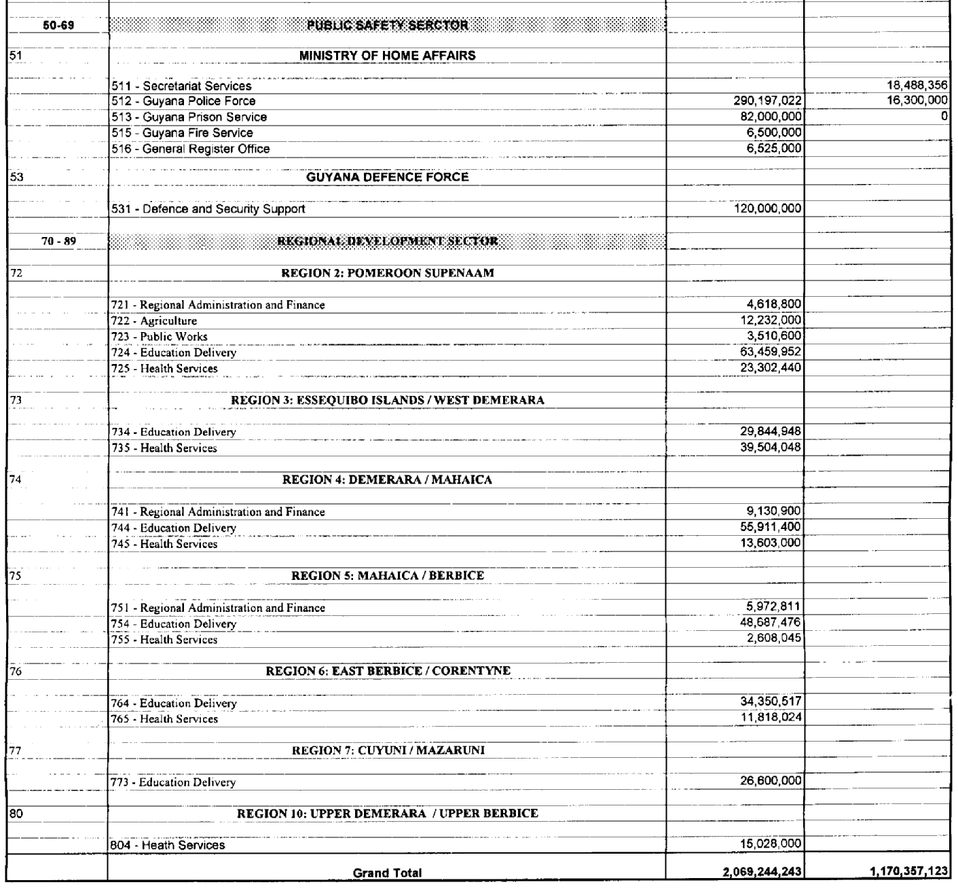

Passed by the National Assembly on 30th December, 2015.

S.E. Isaacs,
Clerk of the National Assembly.

(BILL No. 18/2015)

