THE OFFICIAL GAZETTE 6TH JANUARY, 2016
LEGAL SUPPLEMENT — A

GUYANA

ACT NO. 12 of 2015

FINANCIAL INSTITUTIONS (AMENDMENT) ACT 2015

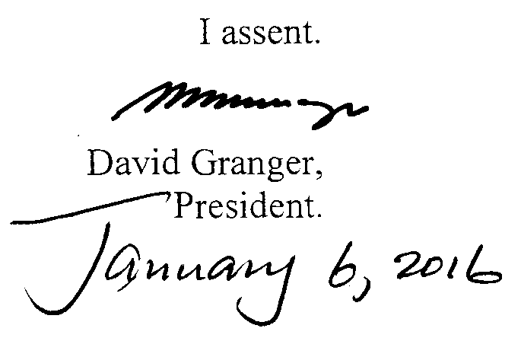

ARRANGEMENT OF SECTIONS

SECTION

1. Short title.
2. Amendment of section 63 of the Principal Act.

AN ACT to amend the Financial Institutions Act.

A. D. 2015  Short title.  Cap. 85:03  Amendment of section 63 of the Principal Act.  Cap. 79:04 |  | Enacted by the Parliament of Guyana:-  1. (1) This Act, which amends the Financial Institutions Act, may be cited as the Financial Institutions (Amendment) Act 2015.  2. Section 63 of the Principal Act is hereby amended in the following manner-  (a) by the deletion of the word “or” at the end of paragraph (iii); and  (b) by the insertion immediately after paragraph (iii) of the following paragraph as paragraph (iiiA) –  “(iiiA) to the Revenue Authority, established under the Revenue Authority Act, in response to a lawful requirement, a lawful request or demand of the Revenue Authority; or “.

Passed by the National Assembly on the 17th December, 2015.

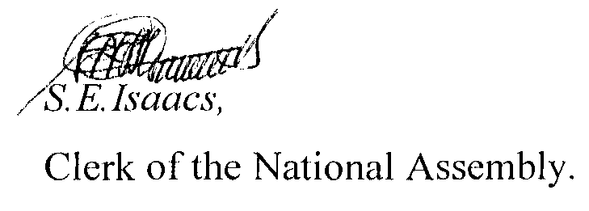

(BILL No. 10/2015)

