THE OFFICIAL GAZETTE 6TH JANUARY, 2016
LEGAL SUPPLEMENT — A

GUYANA

ACT NO. 11 of 2015

MUNICIPAL AND DISTRICT COUNCILS AND LOCAL AUTHORITIES (ELECTIONS) (AMENDMENT) ACT 2015

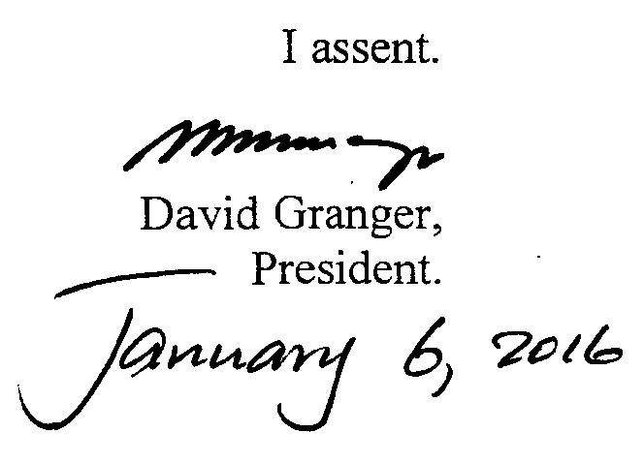

ARRANGEMENT OF SECTIONS

SECTION

1. Short title.
2. Amendment of Section 23 of the Municipal and District Council Act.
3. Amendment of Section 32 of the Municipal and District Council Act.
4. Amendment of Section 35 of the Municipal and District Council Act.
5. Amendment of Section 40 of the Municipal and District Council Act.
6. Amendment of Section 44A of the Local Authorities (Elections) Act.

AN ACT to amend the Municipal and District Councils Act and the Local Authorities (Elections) Act.

A. D. 2015  Short title.  Cap. 28:01  Cap. 28:03.  Amendment of section 23 of the Municipal and District Councils Act.  Amendment of section 32 of the Municipal and District Councils Act.  Amendment of section 35 of the Municipal and District Councils Act.  Amendment of section 40 of the Municipal and District Councils Act.  Amendment of section 44A of the Local Authorities (Elections) Act. |  | Enacted by the Parliament of Guyana:-  1. (1) This Act, which amends the Municipal and District Councils Act and the Local Authorities (Elections) Act, may be cited as the Municipal and District Councils and Local Authorities (Elections) (Amendment) Act 2015.  2. Section 23 (3) of the Municipal and District Councils Act is amended by the insertion immediately after the word “candidates” of the words “for the proportional representation component”.  3. Section 32 (3) of the Municipal and District Councils Act is amended bt the insertion immediately after the word “candidates” of the words “for the proportional representation component”.  4. Section 35 (3) of the Municipal and District Councils Act is amended by the insertion immediately after the word “candidates” of the words “for the proportional representation component”.  5. Section 40 (2) of the Municipal and District Councils Act is amended by the insertion immediately after the word “candidates” of the words “for the proportional representation component” and by the substitution for the words “fifty” and “sixty” of the words “one hundred” and “one hundred and ten”, respectively.  6. Section 44A (4)(a) of the Local Authorities (Elections) Act is amended by the substitution for the words “fifty” and “sixty” of the words “one hundred” and “one hundred” and ten”, respectively.

Passed by the National Assembly on the 17th December, 2015.

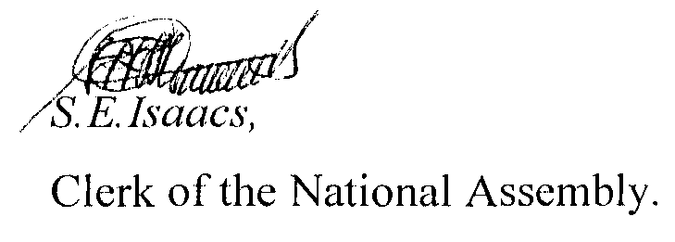

(BILL No. 14/2015)

