THE OFFICIAL GAZETTE 15TH SEPTEMBER, 2015
LEGAL SUPPLEMENT — A

GUYANA

ACT NO. 9 OF 2015

LOCAL AUTHORITIES (ELECTIONS) (AMENDMENT) ACT 2015

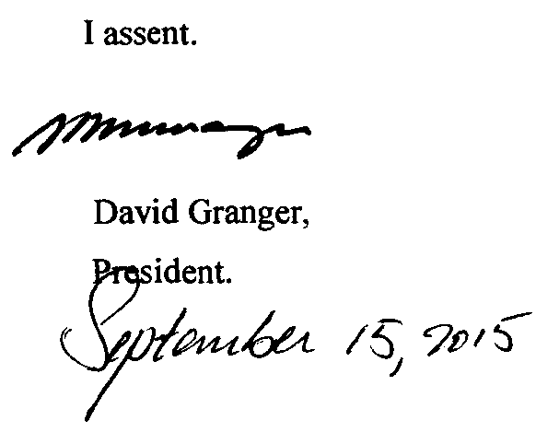

ARRANGEMENT OF SECTIONS

SECTION

- Short title.
- Amendment of section 2 of the Principal Act.
- Amendment of section 5 of the Principal Act.
- Amendment of section 10 of the Principal Act.
- Amendment of section 11 of the Principal Act.
- Amendment of section 12 of the Principal Act.
- Amendment of section 15 of the Principal Act.

- Amendment of section 18 of the Principal Act.
- Amendment of section 20 of the Principal Act.
- Amendment of section 40 of the Principal Act.
- Amendment of section 41 of the Principal Act.
- Amendment of section 46 of the Principal Act.
- Amendment of section 47 of the Principal Act.
- Amendment of section 48 of the Principal Act.
- Amendment of section 49 of the Principal Act.
- Amendment of section 50 of the Principal Act.
- Amendment of section 51 of the Principal Act.
- Amendment of section 53 of the Principal Act.
- Amendment of the Principal Act.
- Amendment of section 62 of the Principal Act.
- Amendment of section 63 of the Principal Act.
- Amendment of section 64 of the Principal Act.
- Amendment of section 65 of the Principal Act.
- Amendment of section 74F of the Principal Act.
- Amendment of section 95 of the Principal Act.
- Amendment of section 101 of the Principal Act.

2
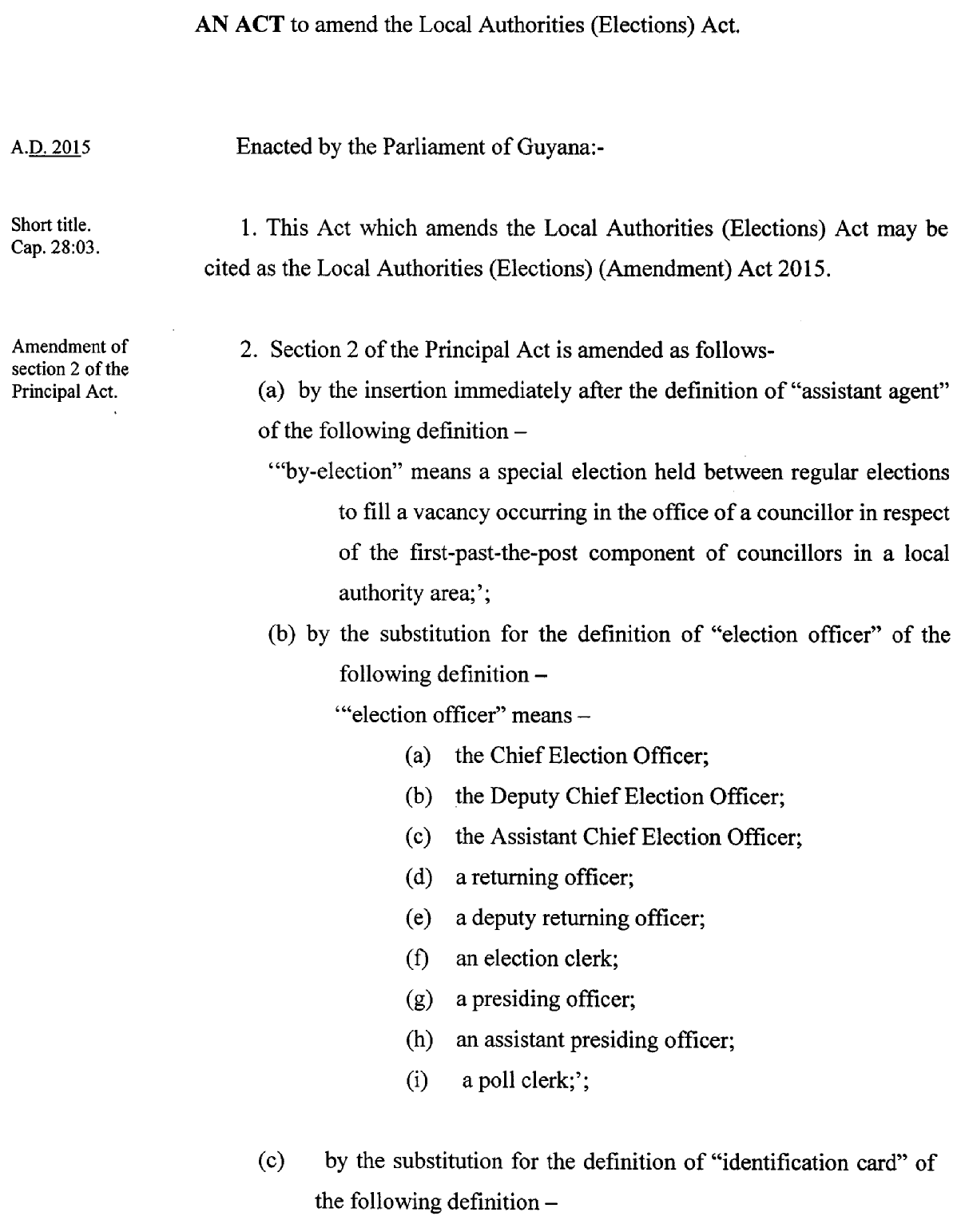

3
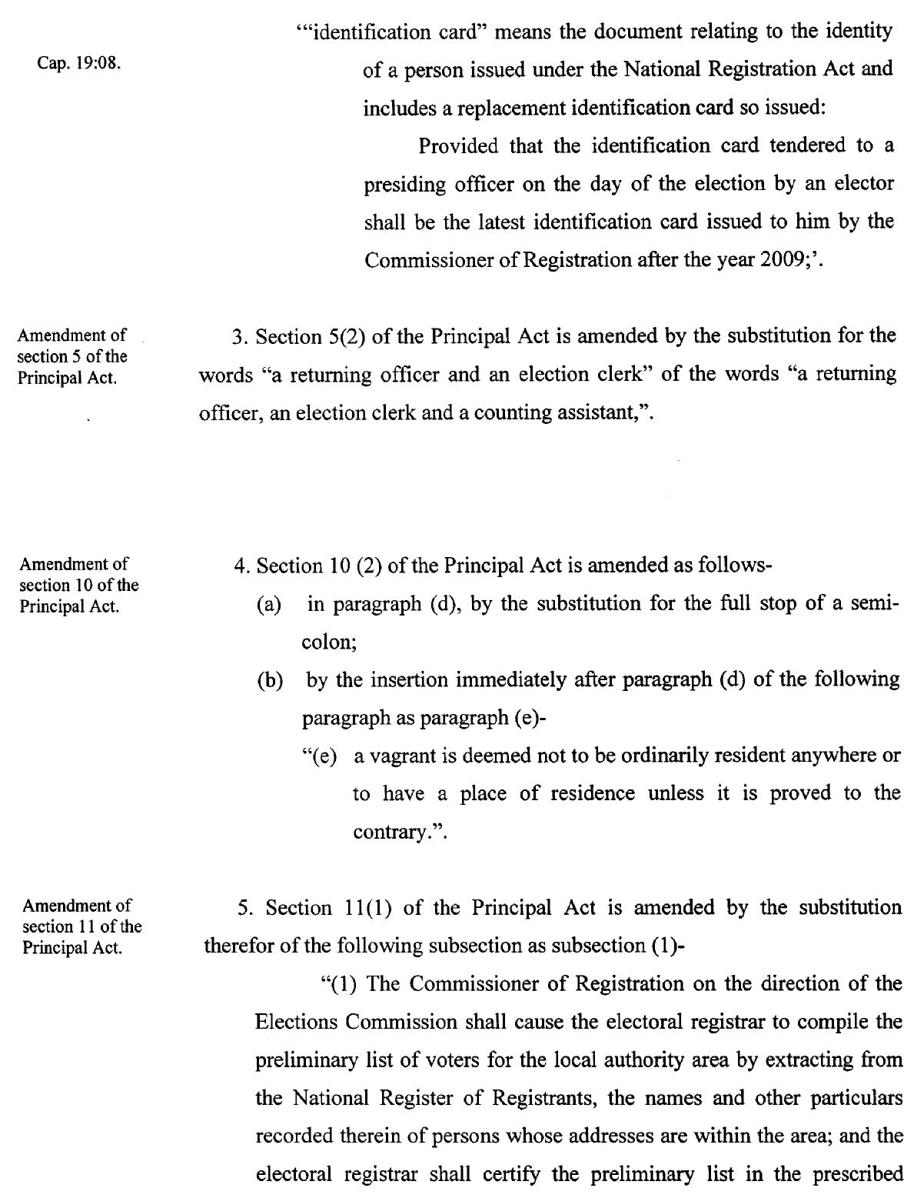

4
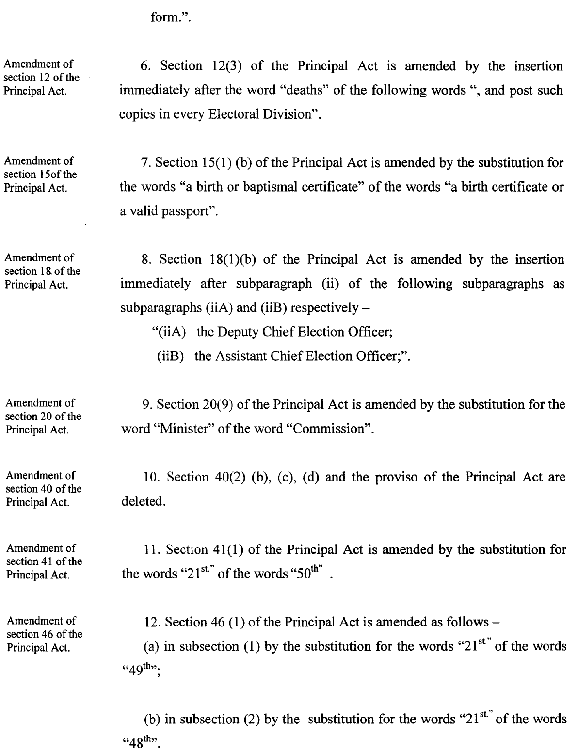

5
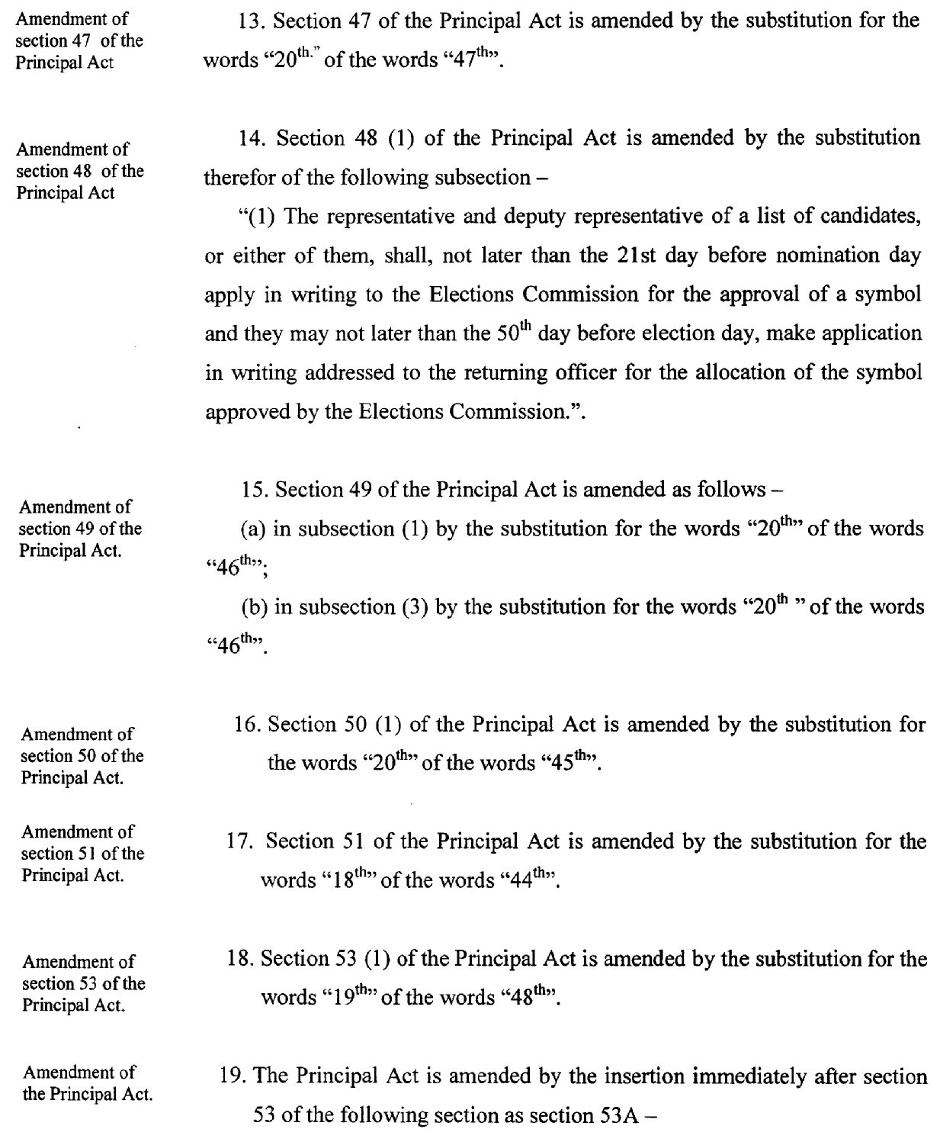

6
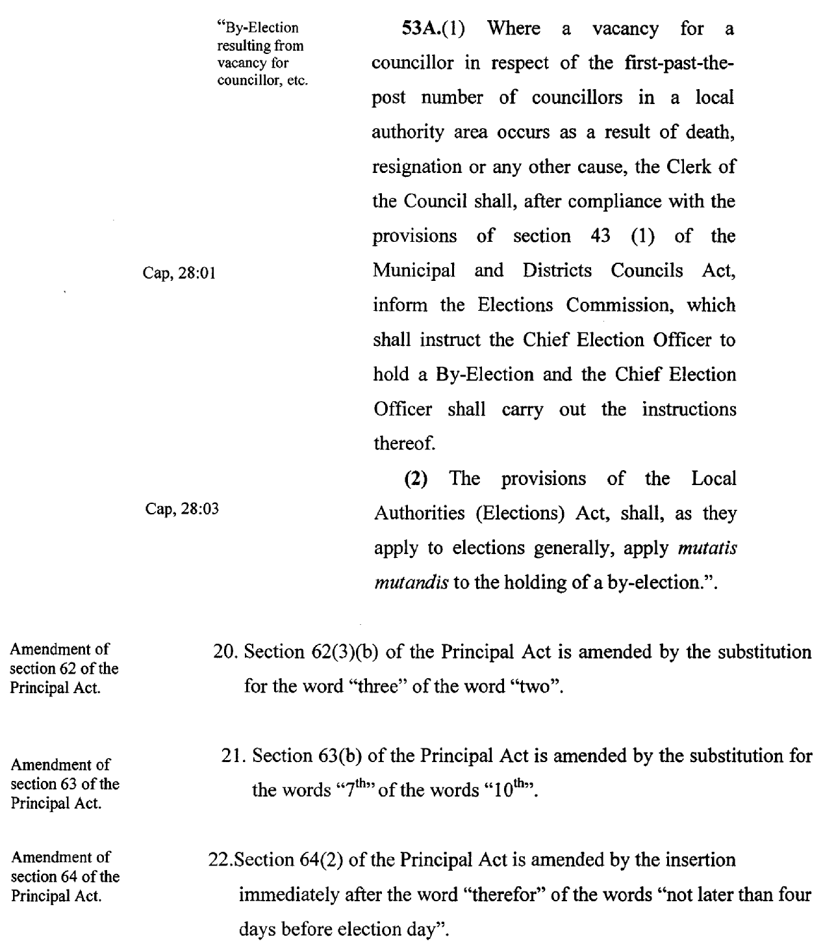

7
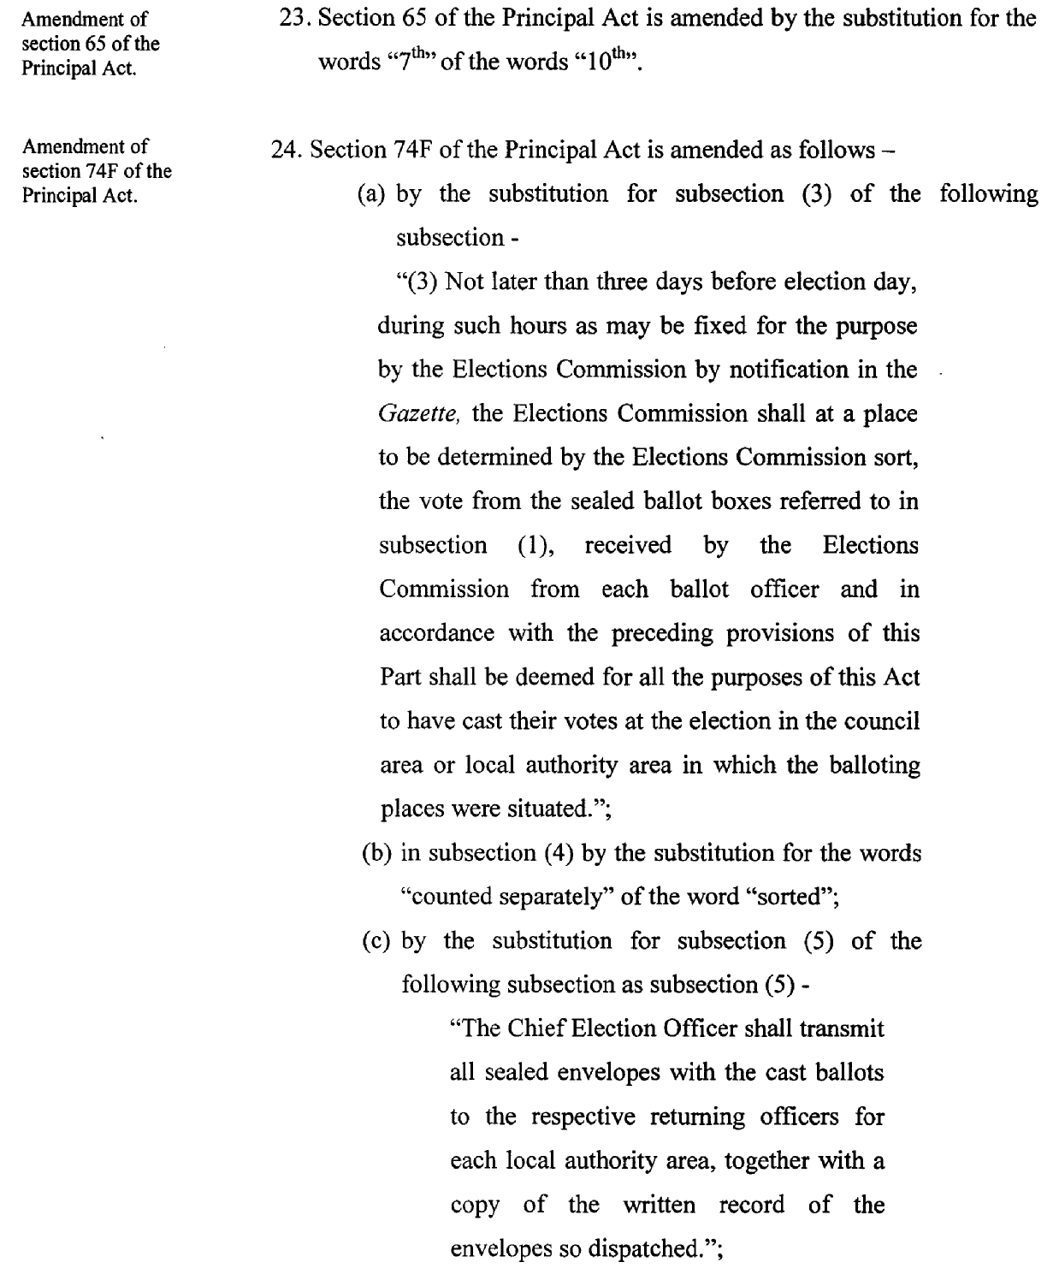

8
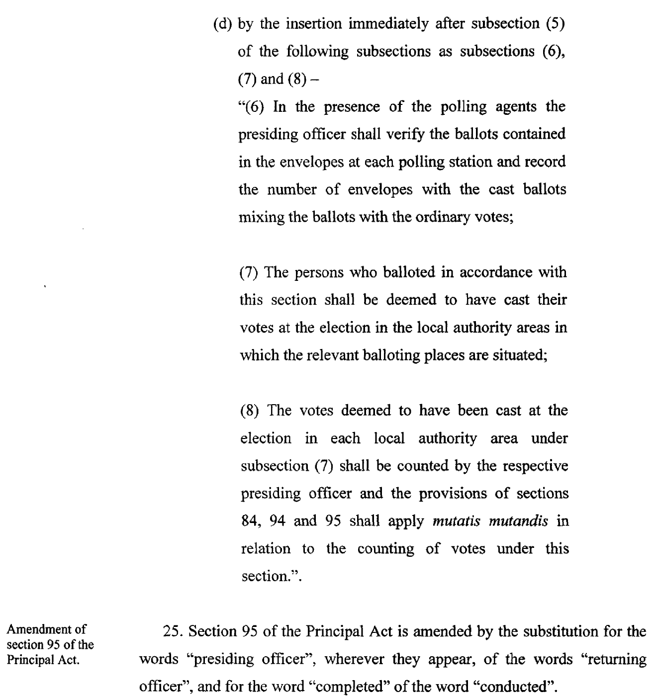

9

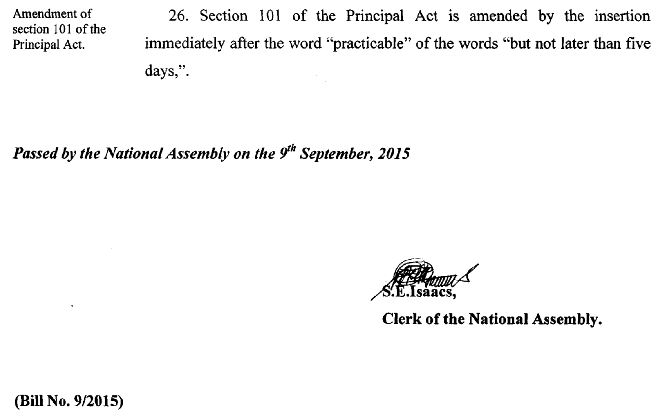

10

