THE OFFICIAL GAZETTE 7TH SEPTEMBER, 2015
LEGAL SUPPLEMENT — A

GUYANA

ACT NO. 8 of 2015

INCOME TAX (AMENDMENT) ACT 2015

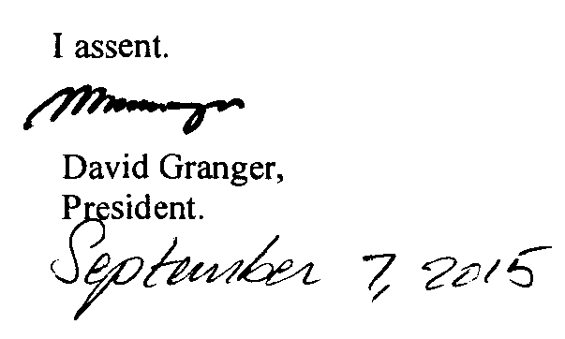

ARRANGEMENT OF SECTIONS

SECTION

1. Short title.
2. Amendment of section 16 of the Principal Act.

AN ACT to amend the Income Tax Act.

A. D. 2015  Short title.  Cap. 81:01  Amendment of section 16 of the Principal Act. |  | Enacted by the Parliament of Guyana:-  1. (1) This Act, which amends the Income Tax Act, may be cited as the Income Tax (Amendment) Act 2015.  (2) The amendments to the Income Tax Act shall come into operation with respect to and form the year of assessment commencing on the 1st January, 2015.  2. Section 16(1) of the Principal Act is amended as follows -  (a) by the substitution for the full stop at the end of paragraph (j) of a semi-colon;  (b) by the insertion immediately after paragraph (j) of the following paragraph as paragraph (k) –  “(k) National Insurance contributions by employees.”.

Passed by the National Assembly on 28th July, 2015.



(BILL No. 8/2015)

