THE OFFICIAL GAZETTE 5TH AUGUST, 2015
LEGAL SUPPLEMENT — A

GUYANA

ACT NO. 4 OF 2015

FISCAL MANAGEMENT AND ACCOUNTABILITY (AMENDMENT) ACT 2015

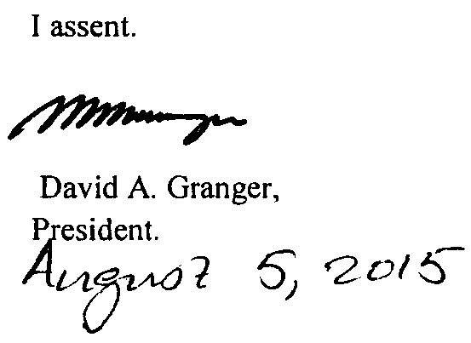

ARRANGEMENT OF SECTIONS

SECTION

1. Short title.
2. Amendment of section 54(1) of the Principal Act.
3. Amendment of the Principal Act.
4. Amendment of Schedule to the Principal Act.

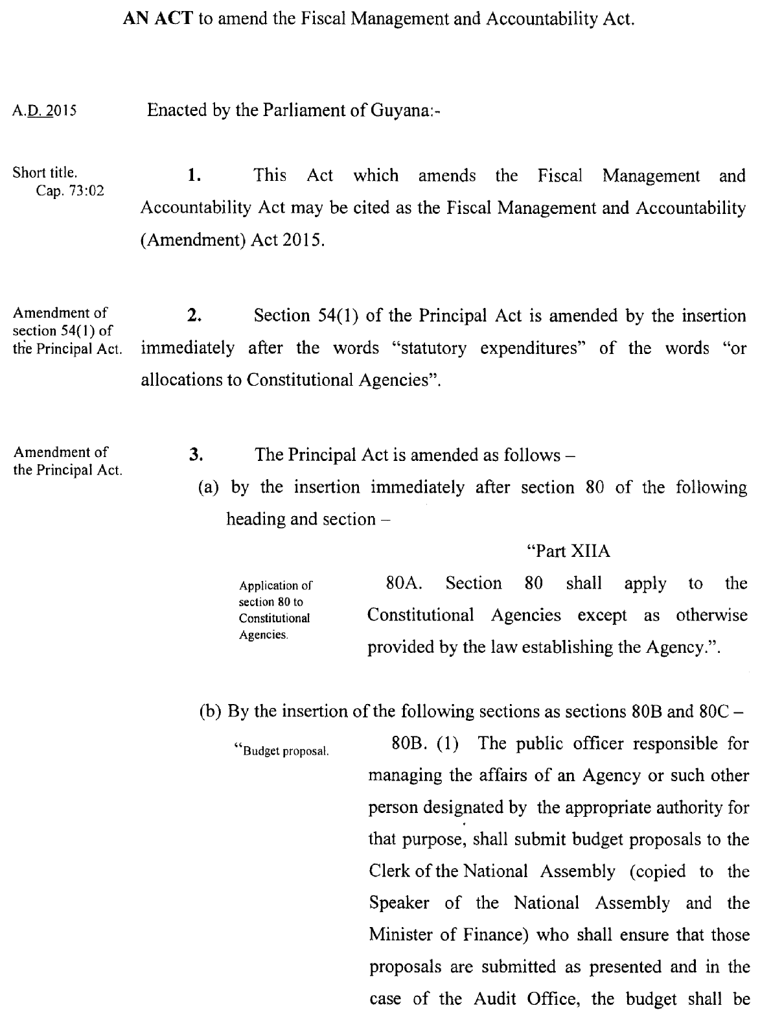

2

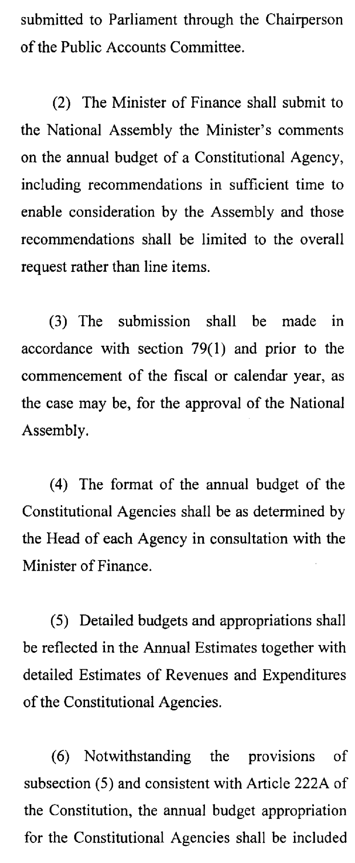

3

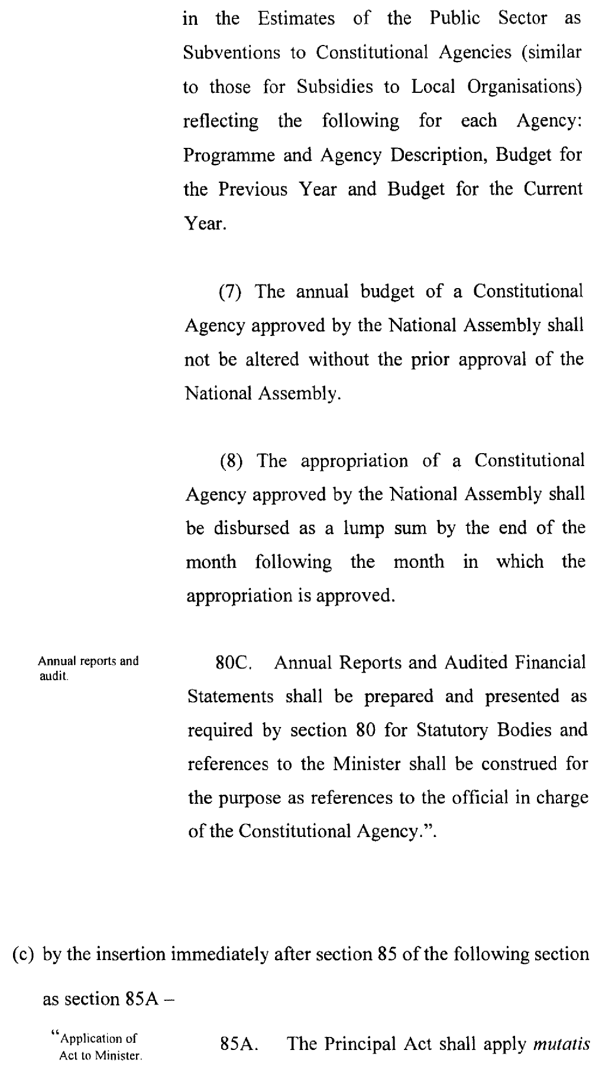

4

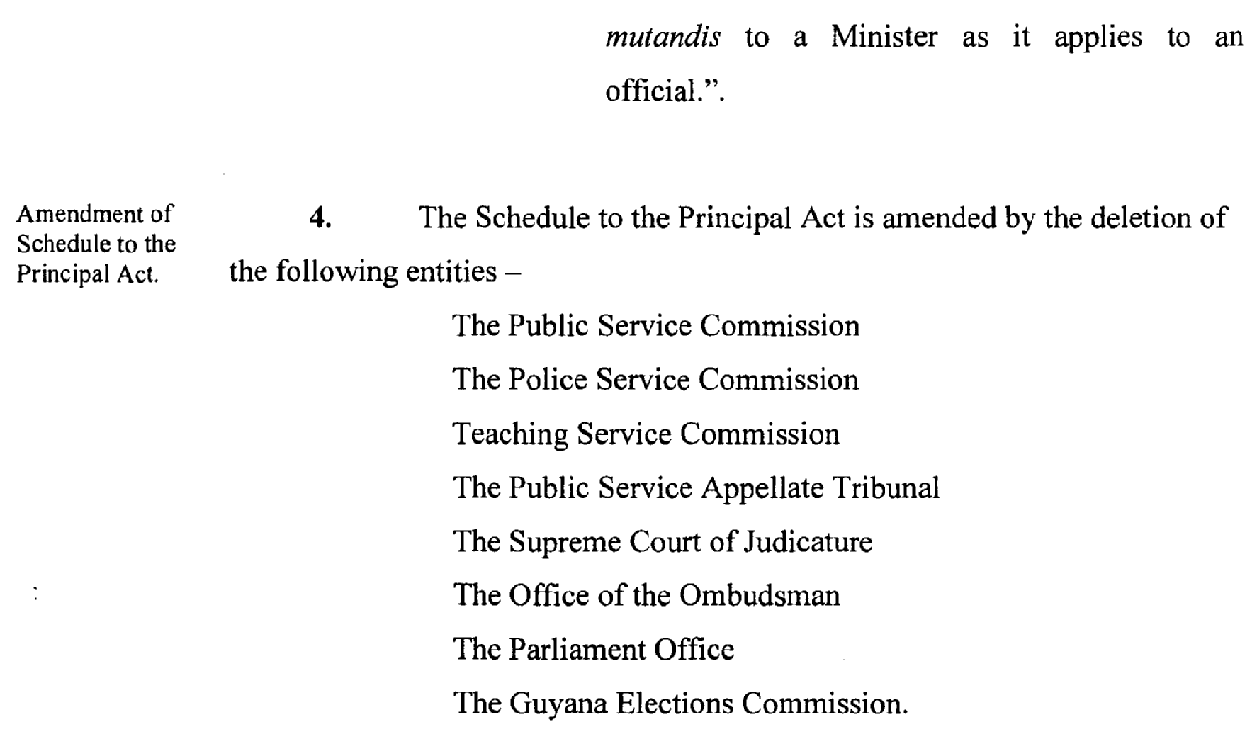

Passed by the National Assembly on the 30th July, 2015



(Bill No. 3/2015)

5

