THE OFFICIAL GAZETTE 10TH JULY, 2015
LEGAL SUPPLEMENT — A

GUYANA

ACT NO. 3 of 2015

FORMER PRESIDENTS (BENEFITS AND OTHER FACILITIES) ACT 2015

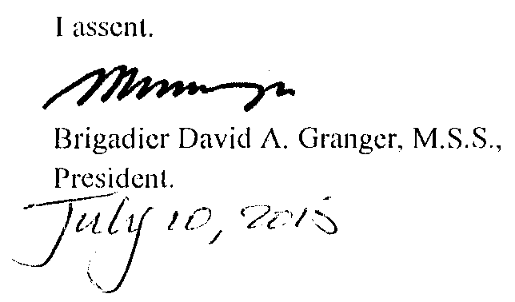

ARRANGEMENT OF SECTIONS

SECTION

1. Short title.
2. Interpretation.
3. Certain benefits and other facilities to former Presidents.
4. No tax exemption on benefits and facilities.
5. Cessation of certain benefits and other facilities of former Presidents.
6. Repeal.
7. Regulations.

AN ACT to provide certain benefits and other facilities for former Presidents.

A. D. 2015  Short title.  Interpretation.  Certain benefits and other facilities for former Presidents. |  | Enacted by the Parliament of Guyana:-  1. This Act may be cited as the Former Presidents (Benefits and other Facilities) Act 2015.  2. In this Act –  “child” means a child of a person whether born in or out of wedlock and child born out of wedlock enjoys equality of status and entitlement to equal rights in accordance with article 149E (1) of the Constitution;  “former President” means any person who has held the office of President substantively;  “spouse” means –  (a) the lawfully married wife or husband of a person;  (b) a single woman living together with a single man in a common law union for period of five years; or  (c) a single man living together with a single woman in a common law union for a period of five years.  3. Every person who has held the office of President substantively shall be entitled to the following benefits and facilities –  (a) payment in respect of expenses incurred for the provision and use of –  (i) water, twenty-five thousand dollars each month;

(ii) electricity, twenty-five thousand dollars each month;
(iii) telephone, twenty-five thousand dollars each month,
at that person’s habitual place of residence in Guyana.

(b) services of personal and household staff including a gardener, provided that the total number of such staff shall not exceed three persons, including any member of the staff who may be on earned vacation or sick leave;

(c) services of clerical and technical staff not exceeding three, if requested, retained for non-political purposes related to the status of former President or to any State related task or assignment to the former President officially and for which no additional remuneration is payable;

(d) subject to a financial limit of two hundred thousand dollars per annum, free medical attention and treatment or reimbursement of medical expenses incurred by —

(i) a former President for himself and his children below the age of eighteen years;

(ii) the spouse of the former President:

Provided that the reimbursement shall not be given where any attention and treatment obtained abroad or at private health facilities in Guyana were available in Guyana at government institutions;

No tax exemption on benefits and facilities.  Cessation of certain benefits and other facilities of former Presidents.  Repeal.  Cap. 27:17  [Act 12 of 2009] |  | (e) full time personal security, not exceeding two persons including the services of the President Guard Service at the place of residence of the former President;  (f) the provision of not more than two motor vehicles owned and maintained by the State;  (g) toll free transportation; and  (h) an annual vacation allowance equivalent to the cost of two first class return airfares provided on the same conditions applicable to judges of the Supreme Court of Judicature.  4. The benefits and facilities granted under section 3 shall not be the subject of any tax exemptions, concessions or privileges.  5. A former President shall cease to be entitled to the benefits and other facilities provided under section 3, if the former President engages in business, trade or paid employment or is convicted of a criminal offence for which a term of imprisonment is imposed.  6. The Former President (Benefits and Other Facilities) Act is repealed.

Passed by the National Assembly on 9th July, 2015.



(BILL No. 2/2015)

