THE OFFICIAL GAZETTE 10TH JULY, 2015
LEGAL SUPPLEMENT — A

GUYANA

ACT NO. 2 OF 2015

CONSTITUTION (AMENDMENT) ACT 2015
ARRANGEMENT OF SECTIONS

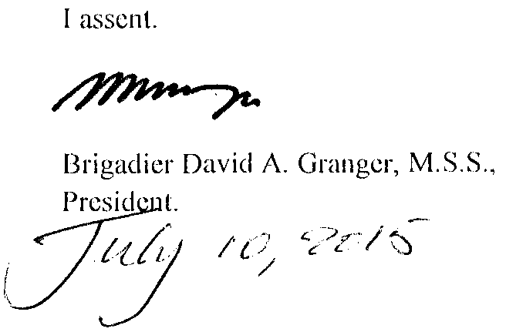

ARRANGEMENT OF SECTIONS

SECTION

1. Short title.
2. Amendment of the Third Schedule to the Constitution.

AN ACT to amend the Third Schedule relating to article 222A of the Constitution to provide financial autonomy to certain entities.

A.D. 2015  Short title.  Amendment of the Third Schedule to the Constitution. |  | Enacted by the Parliament of Guyana:-  1. This Act, which amends the Constitution, may be cited as the Constitution (Amendment) Act 2015.  2. The Third Schedule to the Constitution is amended by the addition to the Schedule of the following entities –  The Chambers of the Director of Public Prosecutions  The Judicial Service Commission  The Public Service Commission  The Police Service Commission  The Teaching Service Commission  The Public Service Appellate Tribunal  The Public Procurement Commission  The Office of the Ombudsman  The Guyana Elections Commission (GECOM).

Passed by the National Assembly on the 9th July, 2015.

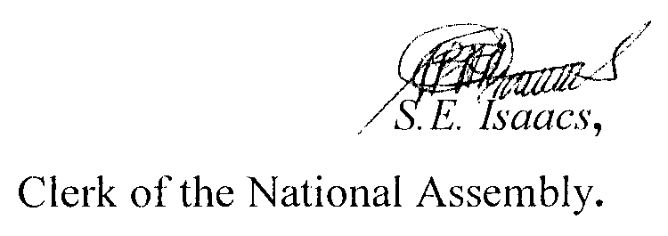
(Bill No. 1/2015)

