THE OFFICIAL GAZETTE 31ST AUGUST, 2015
LEGAL SUPPLEMENT — A

GUYANA

ACT NO. 7 OF 2015

APPROPRIATION ACT 2015

I assent.

David Granger,
President.
August 31, 2015.

ARRANGEMENT OF SECTIONS

SECTION

1. Short title.
2. Issue from the consolidated Fund authorised.
3. Appropriation.

Schedule.

AN ACT to provide for the use from the Consolidated Fund of the sums necessary to meet the expenditure (not otherwise lawfully charged on the Consolidated Fund) of the Cooperative Republic of Guyana for the fiscal year ending 31st December, 2015, estimates whereof have been approved by the National Assembly, and for the appropriation of those sums for the specified purposes, in conformity with the Constitution.

A.D. 2015  Short title.  Issue from the Consolidated Fund authorised.  No. 20 of 2003.  Appropriation.  Schedule. |  | Enacted by the Parliament of Guyana:-  1. This Act may be cited as the Appropriation Act 2015.  2. The issue from the Consolidated Fund of such sums, not exceeding in the aggregate the gross of one hundred and eighty-one billion, six hundred and ninety-seven million and nine hundred and ninety-three thousand dollars ($181,697,993,000), necessary to meet the expenditure of Guyana for the fiscal year ending on 31st December, 2015, is hereby authorised in accordance with Article 218 of the Constitution and Section 17 of the Fiscal Management and Accountability Act 2003.  3. Every sum set out in the Schedule is hereby appropriated for the purposes specified therein with effect from 1st January, 2015.

2
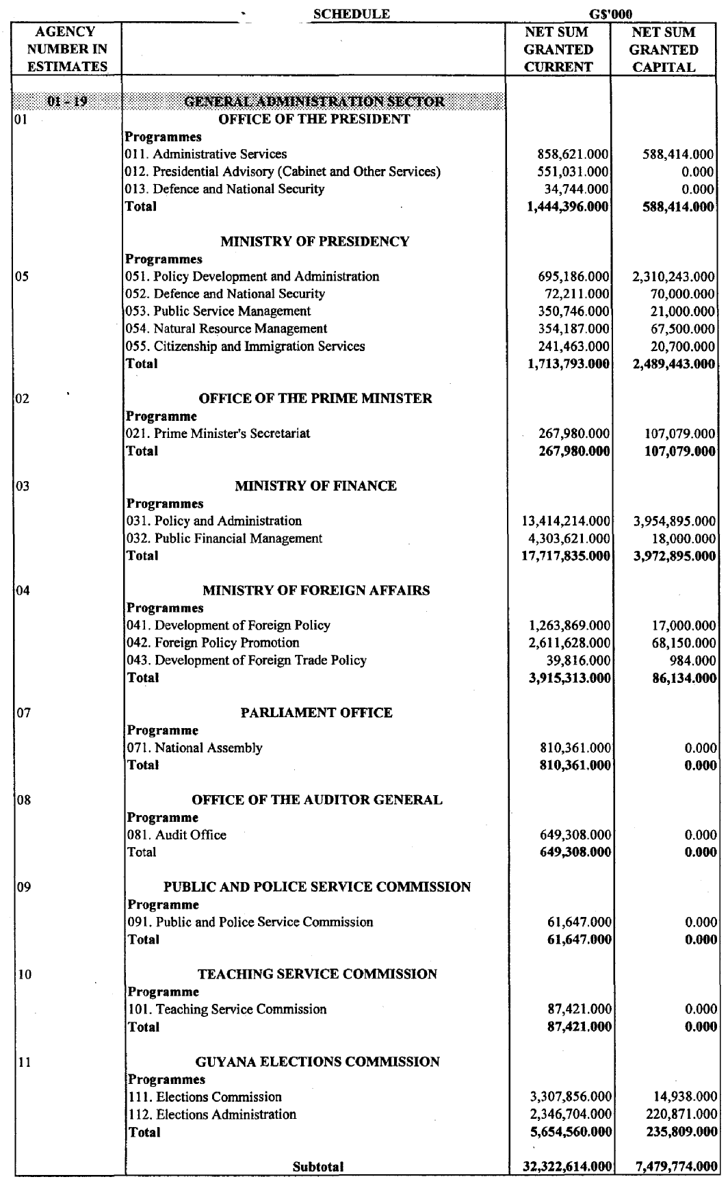

3
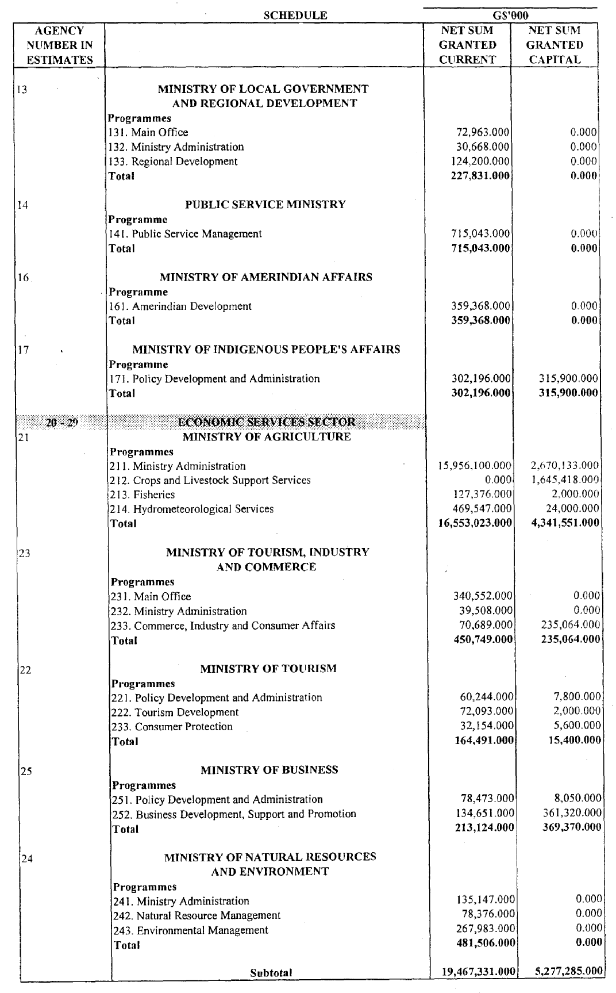

4
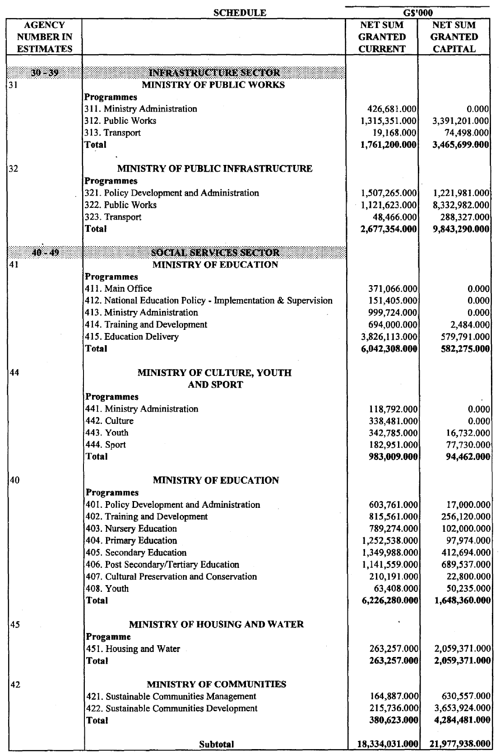

5
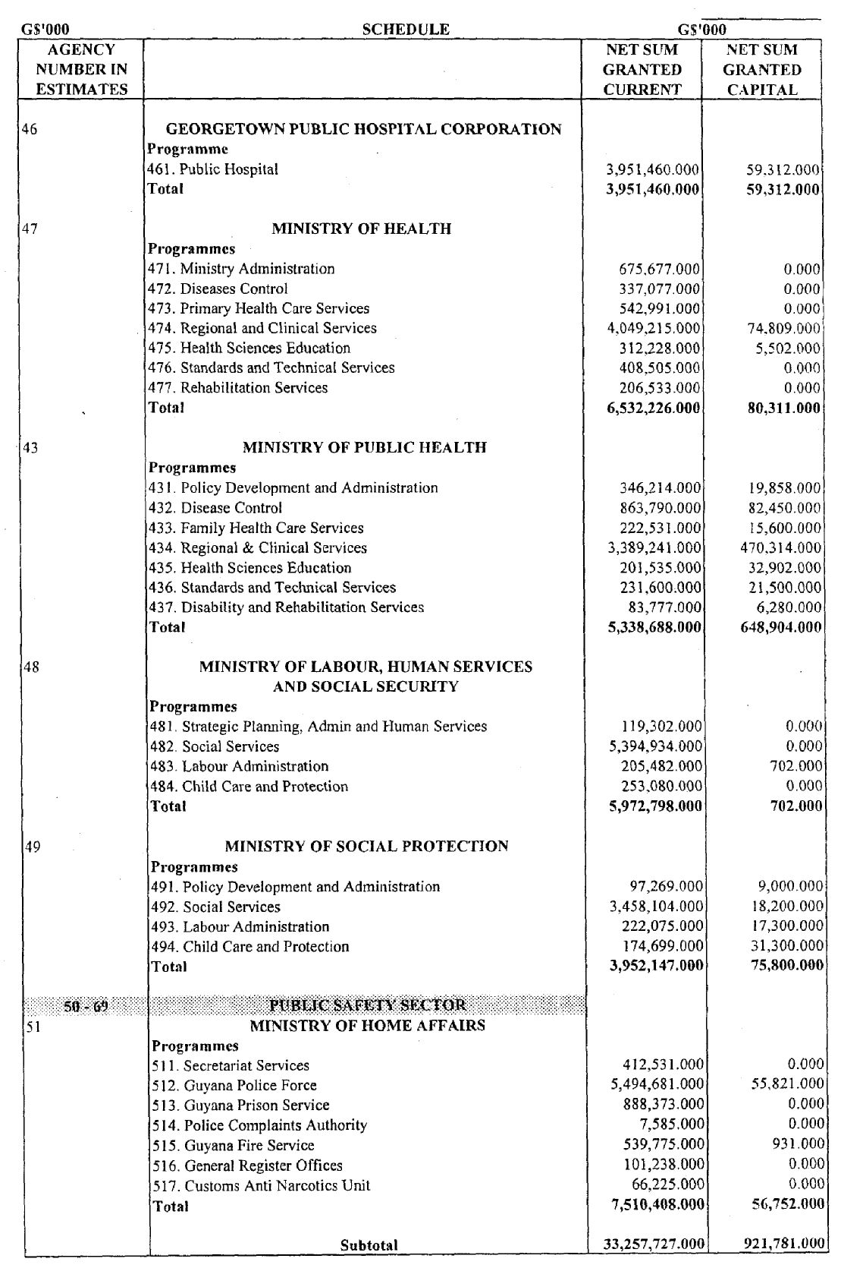

6

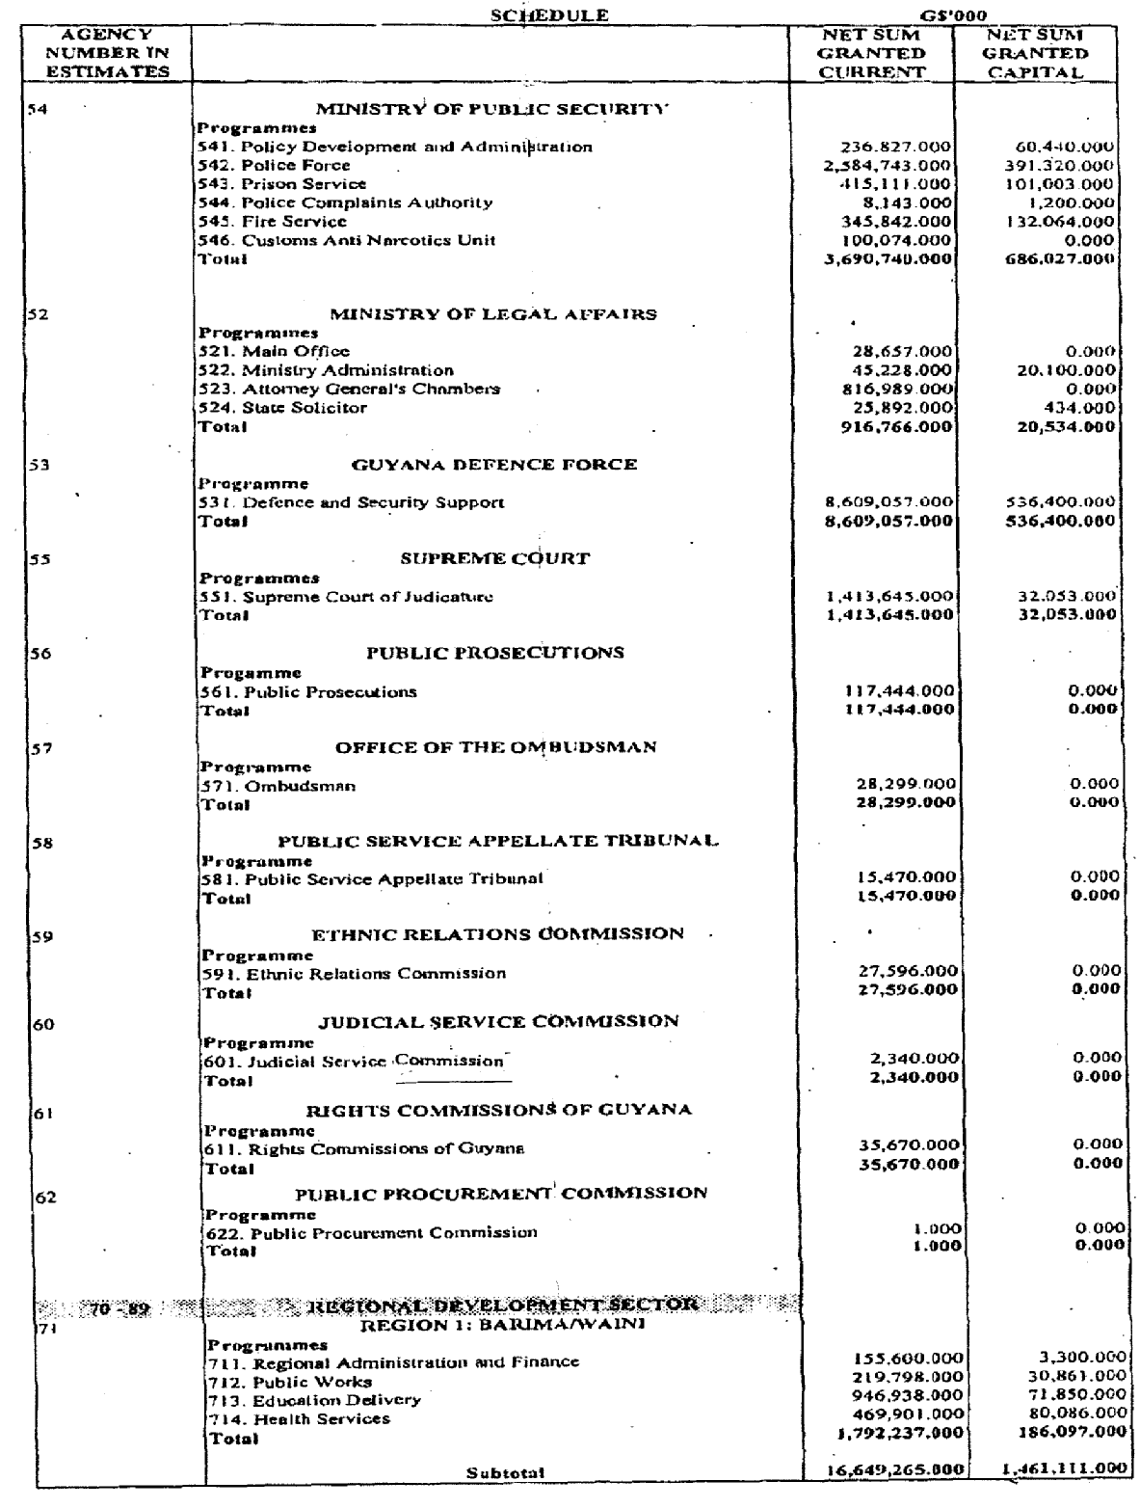

7
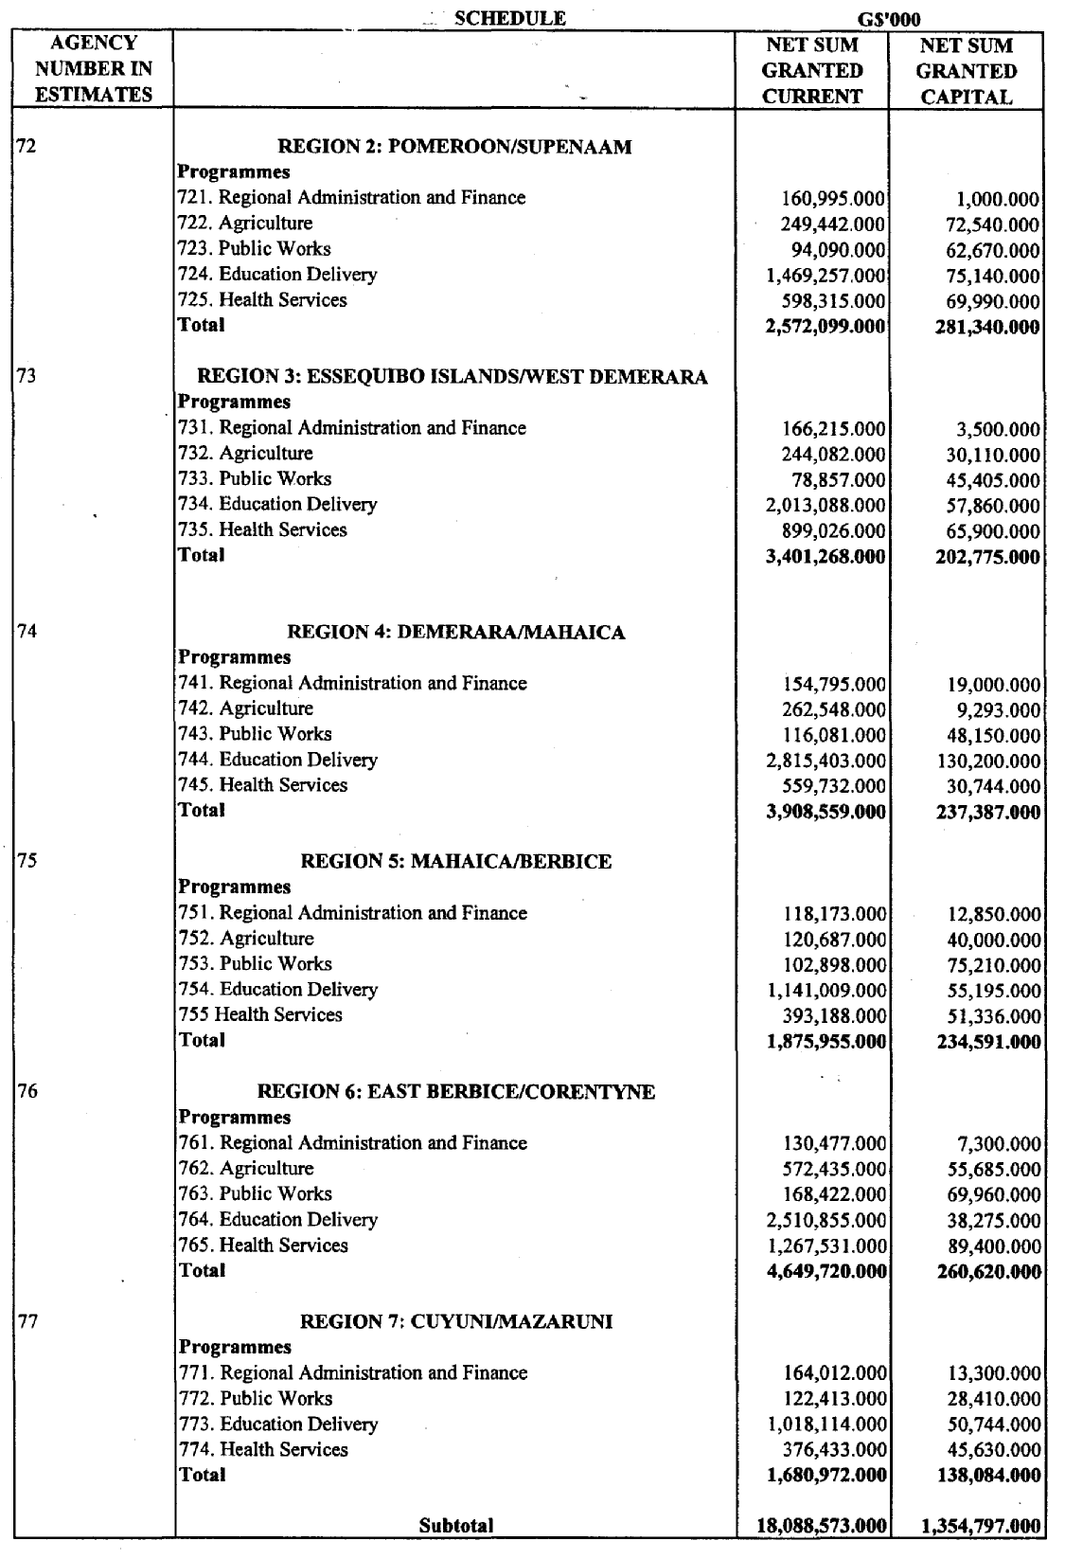

8
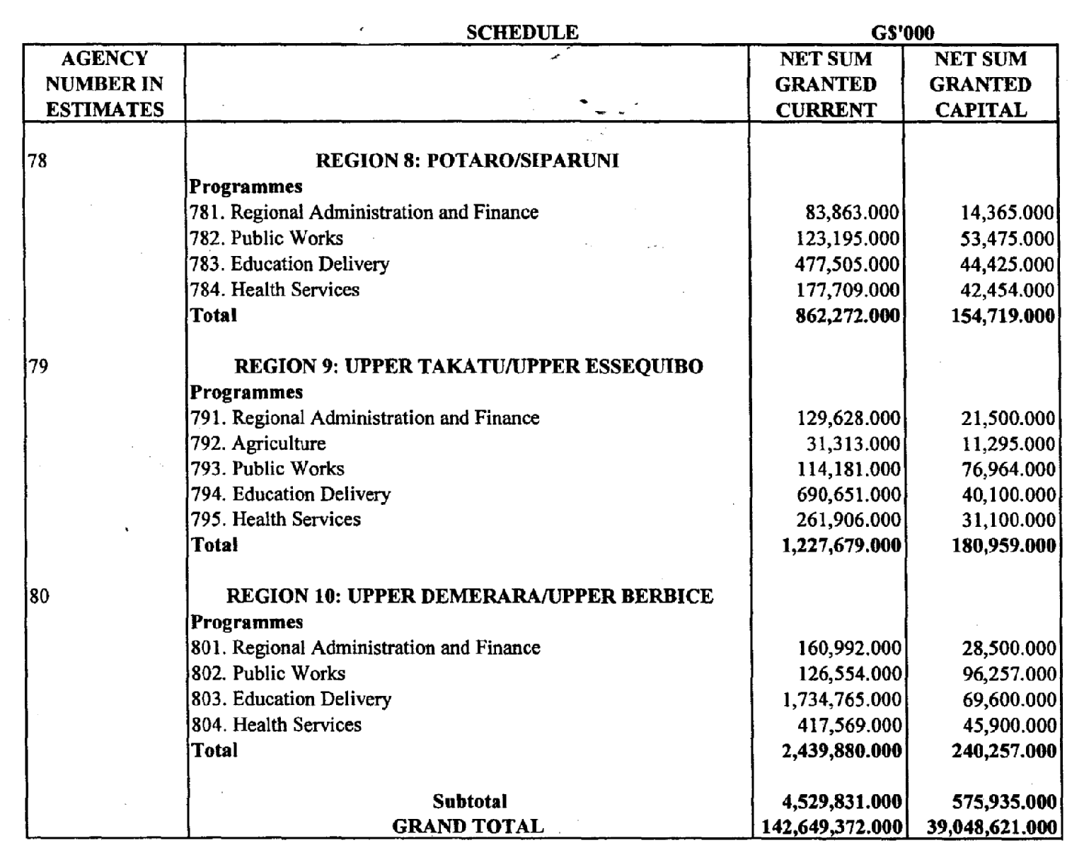



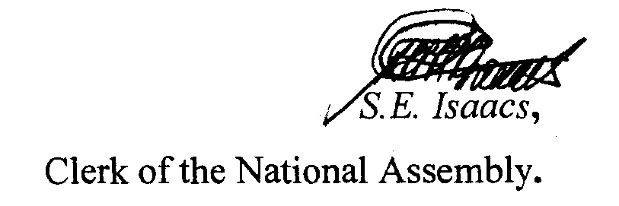

9

