THE OFFICIAL GAZETTE 9TH AUGUST, 2017
LEGAL SUPPLEMENT — A

GUYANA

ACT NO. 19 of 2017

SUPPLEMENTARY APPROPRIATION (NO. 2 FOR 2017) ACT 2017

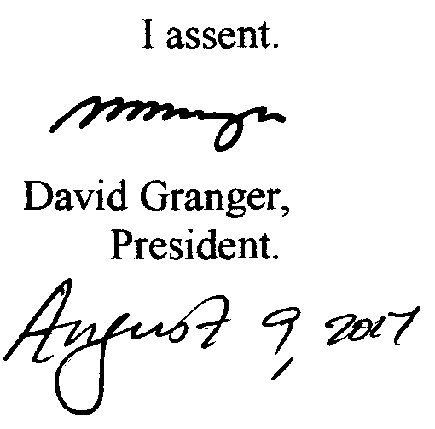

ARRANGEMENT OF SECTIONS

SECTION

1. Short title.
2. Issue from the Consolidated Fund authorised,
3. Appropriation.

Schedule.
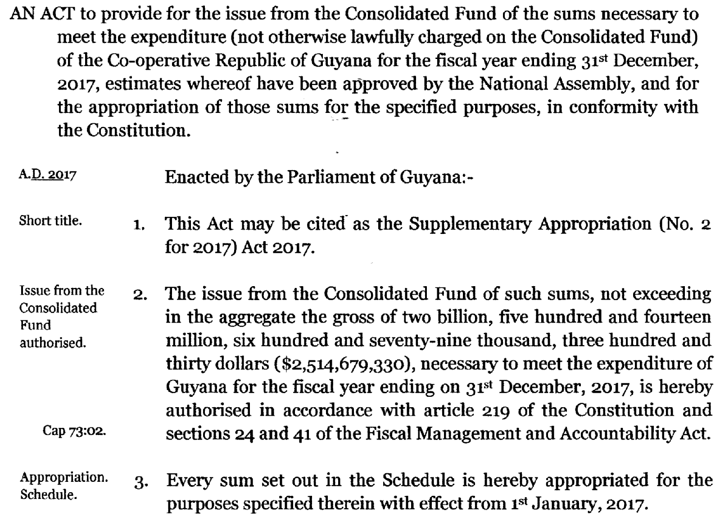

2
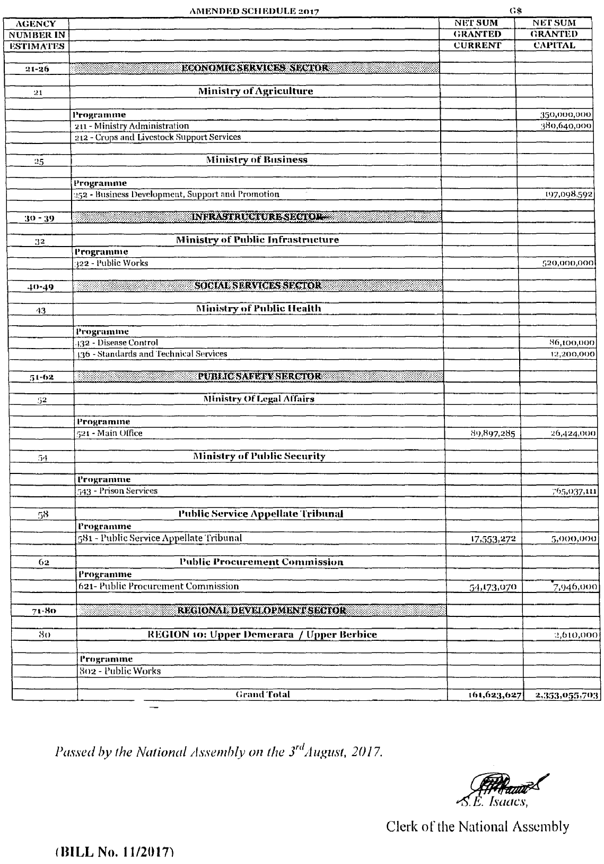

3

